**INTRODUCTION**

**1.INTRODUCTION:**

**1.1 INTRODUCTION TO THE PROJECT:**

Industrial visit is a part of curriculum . It helps to bridge the gap between classroom and the real working world . The visit also provides first-hand knowledge about the organizational structures and modes of operation in different industries.

**1.2 OBJECTIVE OF THE PROJECT:**

The objective of an industrial visit is to provide students with an insight into the corporate world. It provides students with a practical real-world perspective on different functions in organizations such as Marketing, HR, Finance, Operations, Customer Service, Logistics, etc.

**1.3 SCOPE OF THE PROJECT:**

The Scope of industrial visit varies according to courses. Media students visit newspaper office, news channel, printing press as a part of industrial visit .Business students visits big industries where they are exposed to the process of manufacturing including packaging and distribution.hr and operation management students visit all type of organization and study functioning to each department in detail. Engineering students are taken to different companies and industries sites as a part IV. Aeronautical students visit air lines and aviation industries, they also get chance to visit places and jet and understand each part of it.

**1.4 IMPORTANCE OF INDUSTRIAL VISIT:**

#### Industrial visit has its own importance in a career of a student who is pursuing a professional degree. It is considered as a part of college curriculum and objectives of industrial visit is to provide students an insight regarding internal working of companies. We know, theoretical knowledge is not enough for making a good professional career. With an aim to go beyond academics, industrial visit provides student a practical perspective on the world of work.

**1.5 ORGANISATION OF REPORT:**

Report includes the stepwise implementation of the working application generated

and it describes the overview of how effectively the project can be implemented and makes the

viewer of the report to get an overview of the project.

**1.6 FEATURES:**

* In the proposed system, we intend to develop a web-based application providing the necessary services and knowledge about the industries present in the world.
* Admin has the authority to see the students who have registered, logged and signed in.
* The registered students can post a reply online and get their responses from the admin.

**SYSTEM REQUIREMENTS**

**2. SYSTEM SPECIFICATIONS**

**2.1 SOFTWARE REQUIREMENTS:**

* Operating System : Windows
* Web Technologies : Html, JavaScript, CSS,php
* Web Server : Xampp
* Database : phpmyadmin
* IDE :Sublime Text

**2.2 HARDWARE REQUIREMENTS:**

* Processor : Intel core i5 (8th gen).
* RAM : 64GB .
* ROM : 2 Tera byte.

**3. DESIGN AND IMPLEMENTATION**

**3.1 INTRODUCTION**

**DEFINITION:**

The most creative and challenging face of the system development is System Design. It provides the understanding and procedural details for the logical and physical stages of development. In designing a new system, the system analyst must have a clear idea about the objectives of the project, which the design is aiming to fulfill. The first step is to determine how the output is going to be produced. Second, input data and master files have to be designed to meet the requirements of the proposed output. The analyst must have the idea about the outlook of the project. The operational phases are handled through program construction and testing.

System Design can be defined as a process of applying various techniques and principles for the purpose of defining a device, a process or a system in sufficient detail to permit its physical realization. Thus system design is a solution to “how to” approach to the creation of a new system. This important phase provides the understanding and the procedural details, necessary for implementing the feasibility study. The design step provides a data design, architectural design and a procedural design.

**DFD FOR INDUSTRIAL VISIT MANAGEMENT SYSTEM:**

MENTOR

STUDENT

Student details ,

Login details

Register students

View Replies

Add students, send replies

View signup details

**Fig 3.industrial visit system.**

**MODULE SPECIFICATIONS**

After careful analysis, the system has been identified to have the following modules:

1. Administrator Module
2. Student Module

**1. ADMINISTRATOR MODULE**

If we consider the hierarchy of the system the admin will stand at the top and remains as head .The administrator manages student details who register with the system, by creating their profiles. Administrator also manages details of students in the system.

**DFD FOR ADMIN MODULE**

**LOGIN**

**VIEW STUDENT**

**DETAILS**

**Fig 3.1 ADMIN MODULE**

**2. STUDENT MODULE**

A student must register and complete login and signup formalities before one can begin accessing the information. A student can interact with the industry members.

**DFD FOR STUDENT MODULE**

**LOGIN**

**LEAVES REPLY**

**Fig 3.2 Student module.**

**3.2 DESCRIPTION OF FRONT END**

**HYPER TEXT MARKUP LANGUAGE:**

The Hyper Text Markup language (HTML) is a simple markup language used to create hypertext documents that are portable from one platform to another HTML documents are SGML documents with generic semantics that are appropriate for representing information from a wide range of applications. This specifications defines HTML version 4.0 HTML 4.0 aims to capture recommended practice as of early ’96 and as such to be used as a replacement for HTML 3.2

**Why to use HTML:**

Web site is a collection of pages, publications and documentation that reside on web server. While these page publication and a document as a formatted in any single format you should use HTML for home page and all primary pages and the site. This will enable the millions of web users it considered first formatting any new material you plan to publish on the web HTML documents are platform independent, meaning that they don’t conform to any standard it they are created properly you can more home page to any server platform or you can access them with any complaint www browser.

1. **<HTML>…</HTML>** - All HTML files start and end with the tag pair.
2. **<HEAD>…</HEAD>** - All HTML have a pair of “HEAD” tags that indicate what the tile and other attributes of the page are going to be.
3. **<TITLE>…</TITLE>** - this tag indicates what the title of the HTML file is going to be on the BROWSER window title.
4. **<BODY>…</BODY>** - this tag pair is to logically separate the HTML file into the header and the body. Usually the header contains information regarding the html where as the body contains information that the HTML file must actually contain.
5. **The HTML template must look like.**

<! DOCTYPE HTML PUBLIC “THIS IS AN EXAMPLE”>

<HTML>

<HEAD>

<TITLE> YOUR TITLE GOES HERE</TITLE>

</HEAD>

</HTML>

1. **<P>…</P>** - This tag pair used to indicate the paragraph. Any text that needs to be separated into a paragraph must be put in within a paragraph tag.
2. **<B>…</B>** - This tag pair is used to indicate the text within tag pair must be in bold letters.
3. **<I>…</I>** - This tag pair is used to indicate the text within the tag pari must be in italic letters.
4. <**IMG** SRC=”../images/corp.gif” ALT=:LOGO” HEIGHT=”100” WIDTH=”100”> - This tag is used to embed images in the HTML pages. The SRC attribute is used to locate the file name under a directory, the ALT attribute is used to indicate the TOOLTIP message that must appear, and HEIGHT and WIDTH indicate the height and the width of the images that is being shown on the HTML pages.
5. **<H1 ALIGN=”CENTER”>…</H1>** - This pair of tags is used to indicate that the text must be main title for the HTML page. The ALIGN attribute can be used to set the alignment to “center” or “left” or “right”
6. **<H1>Heading1</H1>**

**H2>Heading2</H2>**

**<H3>Heading3</H3>** - This set of tags will show the Headings in smaller fonts as the heading increases.

1. **ALIGN** – The align attribute can be used for headings as well. For <P>…</P> tags also, the ALIGN attribute can be used.
2. **<BR>** - Used to insert a carriage return in the HTML file. The attribute to be used for this is the CLEAR attribute.
3. **<CENTER>…</CENTER>** - To center the entire block of text this tags are used.
4. **<A>…</A>** - Anchor Tags. These tags are used linking namely hyper linking.

**Example:**

<A HREF=<http://www.ibm.com>>Visit IBM Web Pages</A>

1. **Images Basics**: Image Tag is used to embed images in the html document. The general syntax is

<IMG SRC=”logo.gif”>

1. **<TABLE>…</TABLE>** - This is used to specify the table type of layout in the HTML document.

<TABLE BORDER=”1”>

<TR>

<TH>Car</TH>

<TH>Company</TH>

</TR>

<TR>

<TH>Concorde</TH>

<TH>Chrysler</TH>

</TR>

</TABLE>

1. **Fonts**: The <FONT> …</FONT> tag is used to specify text in a particular font.

**Example:**

<FONT SIZE=”10”> this is a line of text with size 10</FONT>

Syntax :<FONT>…</FONT>

**3.4 DESCRIPTION OF SERVER LANGUAGE**

**Features of PHP:**

**PHP** is a general-purpose server-side scripting language originally designed for Web development to produce dynamic Web pages. It is one of the first developed server-side scripting languages to be embedded into an HTML source document rather than calling an external file to process data. The code is interpreted by a Web server with a PHP processor module which generates the resulting Web page. It also has evolved to include a command-line interface capability and can be used in standalone graphical applications. PHP can be deployed on most Web servers and also as a standalone shell on almost every operating system and platform free of charge. A competitor to Microsoft's Active Server Pages (ASP) server-side script engine and similar languages, PHP is installed on more than 20 million Web sites and 1 million Web servers. Software that uses PHP includes Joomla, WordPress, MyBB, and Drupal. PHP was originally created by Rasmus Lerdorf in 1995. The main implementation of PHP is now produced by The PHP Group and serves as the formal reference to the PHP language. PHP is free software released under the PHP License, which is incompatible with the GNU General Public License (GPL) due to restrictions on the usage of the term *PHP* While PHP originally stood for "Personal Home Page", it is now said to stand for "PHP: Hypertext Preprocessor", a recursive acronym.

**History**

### Licensing

PHP is free software released under the PHP License, which insists that:

Products derived from this software may not be called "PHP", nor

may "PHP" appear in their name, without prior written permission

from group@php.net. You may indicate that your software works in

conjunction with PHP by saying "Foo for PHP" instead of calling

it "PHP Foo" or "phpfoo"

This restriction on use of the name **PHP** makes it incompatible with the GNU General Public License (GPL).

## Usage

## PHP is a general-purpose scripting language that is especially suited to server-side web development where PHP generally runs on a web server. Any PHP code in a requested file is executed by the PHP runtime, usually to create dynamic web page content or dynamic images used on Web sites or elsewhere. It can also be used for command-line scripting and client-side graphical user interface (GUI) applications. PHP can be deployed on most Web servers, many operating systems and platforms, and can be used with many relational database management systems (RDBMS). It is available free of charge, and the PHP Group provides the complete source code for users to build, customize and extend for their own use.

## PHP acts primarily as a filter, taking input from a file or stream containing text and/or PHP instructions and outputting another stream of data; most commonly the output will be HTML. Since PHP 4, the PHP parser compiles input to produce byte code for processing by the Zend Engine, giving improved performance over its interpreter predecessor.

## Originally designed to create dynamic Web pages, PHP now focuses mainly on server-side scripting, and it is similar to other server-side scripting languages that provide dynamic content from a Web server to a client, such as Microsoft's ASP.NET, Sun Microsystems'JavaServer Pages, and mod_perl. PHP has also attracted the development of many frameworks that provide building blocks and a design structure to promote rapid application development (RAD). Some of these include CakePHP, Symfony, CodeIgniter, Yii Framework, and Zend Framework, offering features similar to other web application frameworks.

The LAMP architecture has become popular in the Web industry as a way of deploying Web applications. **PHP** is commonly used as **P** in this module alongside Linux, Apache and MySQL, although the P may also refer to Python or Perl or some mix of the three. Similar packages are also available for Windows and OS X, then called WAMP and MAMP, with the first letter standing for the respective operating system.

## As of April 2007, over 20 million Internet domains had Web services hosted on servers with PHP installed and mod_php was recorded as the most popular Apache HTTP Server module.  PHP is used as the server-side programming language on 75% of all Web sites. Web content management systems written in PHP include MediaWiki, Joomla, eZ .

## Syntax:

<!DOCTYPE html>

<html>

<head>

<meta charset="utf-8">

<title>PHP Test</title>

</head>

<body>

**<?php**

echo'Hello World';

**?>**

</body>

</html>

Hello world program in PHP code embedded in HTML code

The PHP interpreter only executes PHP code within its delimiters. Anything outside its delimiters is not processed by PHP (although non-PHP text is still subject to control structures described in PHP code). The most common delimiters are <?php to open and ?> to close PHP sections. <script language="php"> and </script> delimiters are also available, as are the shortened forms <? or <?= (which is used to echo back a string or variable) and ?> as well as ASP-style short forms <%or <%= and %>. While short delimiters are used, they make script files less portable as support for them can be disabled in the PHP configuration, and so they are discouraged. The purpose of all these delimiters is to separate PHP code from non-PHP code, including HTML.

The first form of delimiters, <?php and ?>, in XHTML and other XMLdocuments, creates correctly formed XML 'processing instructions'.This means that the resulting mixture of PHP code and other markup in the server-side file is itself well-formed XML.

Variables are prefixed with a dollar symbol, and a type does not need to be specified in advance. Unlike function and class names, variable names are case sensitive. Both double-quoted ("") and heredoc strings provide the ability to interpolate a variable's value into the string. PHP treats newlines as whitespace in the manner of a free-form language (except when inside string quotes), and statements are terminated by a semicolon. PHP has three types of comment syntax: /* */ marks block and inline comments; //as well as # are used for one-line comments.The echo statement is one of several facilities PHP provides to output text, *e.g.*, to a Web browser.

In terms of keywords and language syntax, PHP is similar to most high level languages that follow the C style syntax. *if* conditions,*for* and *while* loops, and function returns are similar in syntax to languages such as C, C++, Java and Perl.

### Data types

PHP stores whole numbers in a platform-dependent range, either a 64-bit or 32-bit signed integer equivalent to the C-language long type. Unsigned integers are converted to signed values in certain situations; this behavior is different from other programming languages. Integer variables can be assigned using decimal (positive and negative), octal, and hexadecimal notations. Floating point numbers are also stored in a platform-specific range. They can be specified using floating point notation, or two forms of scientific notation. PHP has a native Boolean type that is similar to the native Boolean types in Java and C++. Using the Boolean type conversion rules, non-zero values are interpreted as true and zero as false, as in Perl and C++. The null data type represents a variable that has no value. The only value in the null data type is *NULL*. Variables of the "resource" type represent references to resources from external sources. These are typically created by functions from a particular extension, and can only be processed by functions from the same extension; examples include file, image, and database resources. Arrays can contain elements of any type that PHP can handle, including resources, objects, and even other arrays. Order is preserved in lists of values and in hashes with both keys and values, and the two can be intermingled.PHP also supports strings, which can be used with single quotes, double quotes, now doc or here doc syntax.

The Standard PHP Library (SPL) attempts to solve standard problems and implements efficient data access interfaces and classes.

### Functions

PHP has hundreds of base functions and thousands more via extensions. These functions are well documented on the PHP site; however, the built-in library has a wide variety of naming conventions and inconsistencies. PHP currently has no functions for thread programming, although it does support multi process programming on POSIX systems.

Additional functions can be defined by a developer:

**function** myFunction(){*//declares a function, this is named myFunction*

return'John Doe';*//returns the value 'John Doe'*

}

echo'My name is '. myFunction().'!';*//outputs the text and the return variable of the*

*//myFunction, the function is also called*

*//the result of the output will be 'My name is John Doe!'*

### Objects

Basic object-oriented programming functionality was added in PHP 3 and improved in PHP 4.Object handling was completely rewritten for PHP 5, expanding the feature set and enhancing performance. In previous versions of PHP, objects were handled like value types. The drawback of this method was that the whole object was copied when a variable was assigned or passed as a parameter to a method. In the new approach, objects are referenced by handle, and not by value. PHP 5 introduced private and protected member variables and methods, along with abstract classes, final classes, abstract methods, and final methods. It also introduced a standard way of declaring constructors and destructors, similar to that of other object-oriented languages such as C++, and a standard exception handling model. Furthermore, PHP 5 added interfaces and allowed for multiple interfaces to be implemented. There are special interfaces that allow objects to interact with the runtime system. Objects implementing Array Access can be used with array syntax and objects implementing Iterator or Iterator Aggregate can be used with the for each language construct. There is no virtual table feature in the engine, so static variables are bound with a name instead of a reference at compile time

**class** Person {

**public** $firstName;

**public** $lastName;

**public function** __construct($firstName,$lastName=''){*//Optional parameter*

$this->firstName=$firstName;

$this->lastName=$lastName;

}

**Public function** greet(){

return"Hello, my name is ".$this->firstName." ".$this->lastName.".";

}

**public** static **function** static Greet($firstName,$lastName){

return"Hello, my name is ".$firstName." ".$lastName.".";

}

}

$he=**new** Person('John','Smith');

$she=**new** Person('Sally','Davis');

$other=**new** Person('Joe');

echo$he->greet();*// prints "Hello, my name is John Smith."*

echo'<br />';

echo$she->greet();*// prints "Hello, my name is Sally Davis."*

echo'<br />';

echo$other->greet();*// prints "Hello, my name is Joe ."*

echo'<br />';

echo Person::staticGreet('Jane','Doe');*// prints "Hello, my name is Jane Doe."*

Visibility of properties and methods

The visibility of PHP properties and methods refers to visibility in PHP. It is defined using the keywords public, private, and protected. The default is public, if only var is used; var is a synonym for public. Items declared public can be accessed everywhere. protected limits access to inherited classes (and to the class that defines the item). private limits visibility only to the class that defines the item. Objects of the same type have access to each other's private and protected members even though they are not the same instance. PHP's member visibility features have sometimes been described as "highly useful."However, they have also sometimes been described as "at best irrelevant and at worst positively harmful."

## Speed optimization

PHP source code is compiled on-the-fly to an internal format that can be executed by the PHP engine. In order to speed up execution time and not have to compile the PHP source code every time the Web page is accessed, PHP scripts can also be deployed in executable format using a PHP compiler.

Code optimizers aim to enhance the performance of the compiled code by reducing its size, merging redundant instructions and making other changes that can reduce the execution time. With PHP, there are often opportunities for code optimization. An example of a code optimizer is the Accelerator PHP extension.

Another approach for reducing compilation overhead for PHP servers is using an opcode cache. Opcode caches work by caching the compiled form of a PHP script (opcodes) in shared memory to avoid the overhead of parsing and compiling the code every time the script runs. An opcode cache, APC, is planned to be built into an upcoming release of PHP. Opcode caching and code optimization can be combined for best efficiency, as the modifications do not depend on each other (they happen in distinct stages of the compilation).

**XAMPP**

**XAMPP**  is a free and open source cross-platform web server solution stack package, consisting mainly of the Apache HTTP Server, MySQL database, and interpreters for scripts written in the PHP and Perl programming languages.

XAMPP's name is an acronym for:

* X (to be read as "cross", meaning cross-platform)
* Apache HTTP Server
* MySQL
* PHP
* Perl

The program is released under the terms of the GNU General Public License and acts as a free web server capable of serving dynamic pages. XAMPP is available for Microsoft Windows, Linux, Solaris, and Mac OS X, and is mainly used for web development projects.

**Requirements and features**

XAMPP requires only one zip, tar, 7z, or exe file to be downloaded and run, and little or no configuration of the various components that make up the web server is required. XAMPP is regularly updated to incorporate the latest releases of Apache/MySQL/PHP and Perl. It also comes with a number of other modules including Open SSL and phpMyAdmin. Self-contained, multiple instances of XAMPP can exist on a single computer, and any given instance can be copied from one computer to another.

It is offered in both a full, standard version and a smaller version.

## Components

XAMPP 1.7.7, including

* Apache 2.2.21
* MySQL 5.5.16
* PHP 5.3.8
* phpMyAdmin 3.4.5
* FileZilla FTP Server 0.9.39
* Tomcat 7.0

**3.2 SOURCE CODE**

**ADMIN PAGE**

<html>

<head>

<title></title>

</head>

<body><center>

<form method="POST" action="admin1.php">

username:<input type="text" name="username"/><br>

password:<input type="password" name="password"/><br>

<button name=”login”>SUBMIT</button>

</form>

</center>

</body>

</html>

**ADMINLOGIN.PHP**

<?php

session_start();

$conn=new mysqli("localhost","root","","kavya")or die("not connected");

if(isset($_POST['login']))

{

$user=$_POST['username'];

$pass=$_POST['password'];

$sql="select * from admin where username='$user' and pass = '$pass'";

$res=mysqli_query($conn,$sql);

if($res)

{

echo "login successfull";

}

else

{

echo "login failed";

}

}

?>

**HOME PAGE**

<!doctype html>

<html lang="en">

<head>

<meta charset="UTF-8">

<title>home page</title>

<link rel="stylesheet"href="style.css">

</head>

<body>

<header>

<div class="wrapper">

<div class="logo">

<img src="logo.jpg" alt"">

</div>

<ul class="nav-area">

<li class="active"><a href="Home1.html">Home</a></li>

<li><a href="aboutus.html">About</a></li>

<li><a href="ContactInfo.html">Contact Info</a></li>

<li><a href="loginform.html">Login</a></li>

<li><a href="signinform.html">Sign up</a></li>

</ul>

</div>

<div class="welcome-text">

<h1>Welcome to industrial visit</h1>

<a href="Register.html" class="active">Register</a>

</header>

</body>

</html>

**STYLE SHEET OF HOME PAGE**

*{

margin: 0;

padding: 0;

}

.wrapper{

width:1170px;

margin:auto;

}

header{

background-image:linear-gradient(rgba(0,0,0,0.5),rgba(0,0,0,0.5)),url(register.jpg);

height:100vh;

-webkit-background-size:cover;

background-size:cover;

background-position:center center;

position:relative;

}

.nav-area{

float:right;

list-style:none;

margin-top:30px;

}

.nav-area li{

display:inline-block;

}

.nav-area li a{

color:white;

text-decoration:none;

padding:5px 20px;

font-family:poppins;

font-size:23px;

}

.nav-area li a:hover{

background:#fff;

color:#000;

}

.nav-area li a:active{

background:#fff;

color:#000;

}

.logo img{

width:150px;

float:left;

height:auto;

}

.welcome-text{

position:absolute;

width:600px;

height:300px;

margin:20% 30%;

text-align:center;

}

.welcome-text h1{

text-align:center;

color:#fff;

text-transform:uppercase;

}

.welcome-text a{

border:1px solid #fff;

padding:10px 25px;

text-decoration:none;

text-transform:uppercase;

font-size:14px;

margin-top:20px;

display:inline-block;

color:#fff;

}

.welcome-text a:hover{

background:#fff;

color:#333;

}

**LOGIN PAGE**

<html>

<head><title>Registration form</title>

<style>

h1 {

text-align:center;

color:white;

}

header{

background-image:linear-gradient(rgba(0,0,0,0.5),rgba(0,0,0,0.5)),url(register.jpg);

height:100vh;

-webkit-background-size:cover;

background-size:cover;

background-position:center center;

position:relative;

color:white;

}

</style>

</head>

<body><center>

<form method="POST" action="loginformp.php">

<header>

<h1>Login</h1>

USERNAME:

<input type="text" name="username" placeholder="enter username" required><br><br>

PASSWORD:

<input type="password" name="password" placeholder="enter password" required><br><br>

<button name="login">LOGIN</button>

</header>

</form>

</center>

</body>

</html>

**LOGIN.PHP**

<?php

$conn=new mysqli("localhost","root","","kavya")or die("not connected");

if(isset($_POST['login']))

{

$user=$_POST['username'];

$pass=$_POST['password'];

$sql="INSERT INTO login(username,password) VALUES ('$user','$pass')";

$res=mysqli_query($conn,$sql);

if($res)

{

echo "inserted";

}

else

{

echo "not inserted";

}

}

?>

LOGIN RETREVAL

<?php

$conn=new mysqli("localhost","root","","kavya")or die("not connected");

echo"<table border='5'>

<tr>

<th>Username</th>

<th>Password</th>

</tr>";

$sql="SELECT * FROM login";

$result=mysqli_query($conn,$sql);

if($result)

{

while($row=mysqli_fetch_array($result))

{

echo "<tr><td>";

echo $row['username'].'</td><td>';

echo $row['password'].'</td><td>';

}

}

echo "</table>";

?>

**SIGNUP PAGE**

<html>

<head><title>Registration form</title>

<style>

h1

{

text-align:center;

color:white;

}

header{

background-image:linear-gradient(rgba(0,0,0,0.5),rgba(0,0,0,0.5)),url(register.jpg);

height:100vh;

-webkit-background-size:cover;

background-size:cover;

background-position:center center;

position:relative;

color:white;

}

</style>

<body><center>

<form method="POST" action="signinformp.php">

<header>

<h1>Sign up </h1>

USER NAME:

<input type="text" name="username" placeholder="enter username"><br><br>

PASSWORD:

<input type="password" name="password" placeholder="enter password"><br><br>

CONFIRM PASSWORD:

<input type="password" name="confirm_password"placeholder="confirm password"><br><br>

<button name="login">SIGNUP</button>

</header>

</form></center>

</body>

</html>

**SIGNIN.PHP**

<?php

$conn=new mysqli("localhost","root","","kavya")or die("not connected");

if(isset($_POST['login']))

{

$user=$_POST['username'];

$pass=$_POST['password'];

$cpass=$_POST['confirm_password'];

$sql="INSERT INTO signin(username,password,confirm_password) VALUES ('$user','$pass','$cpass')";

$res=mysqli_query($conn,$sql);

if($res)

{

echo "inserted";

}

else

{

echo "not inserted";

}

}

?>

SIGNUP RETREVAL

<?php

$conn = new mysqli("localhost","root","","kavya") or die("not connected");

echo "<p>list of all logi ids</p>";

echo"<table border='5'>

<tr>

<th>user name</th>

<th>password</th>

<th>confirm password</th>

</tr>";

$sql="SELECT * FROM signin";

$result=mysqli_query($conn,$sql);

if($result)

{

while($row=mysqli_fetch_array($result))

{

echo "<tr><td>";

echo $row['username'].'</td><td>';

echo $row['password'].'</td><td>';

echo $row['confirm password'].'</td><td></tr>';

}

}

echo "</table>";

?>

**REGISTER PAGE**

<html>

<head><title>Registration form</title>

<style>

h1

{

text-align:center;

color:white;

}

header{

background-image:linear-gradient(rgba(0,0,0,0.5),rgba(0,0,0,0.5)),url(register.jpg);

height:100vh;

-webkit-background-size:cover;

background-size:cover;

background-position:center center;

position:relative;

color:white;

}

</style>

</head>

<body><center>

<form method="post" action="connect2.php">

<header>

<h1>Register</h1>

USERNAME:

<input type="text" name="username"placeholder="e.g Alex" required><br><br>

MOBILE:

<input type="number"name="mobile"placeholder="enter phone no" required><br><br>

EMAIL:

<input type="text"name="email"placeholder="enter email" required><br><br>

QUALIFICATION:

<select name="qualification">

<option value="--select--"selected="selected" required>--select--</option>

<option>B.Tech</option>

<option>M.Tech</option>

<option>Arts</option>

<option>MBA</option>

<option>MCA</option>

<option>Secondary Education</option>

<option>Intermediate Education</option>

</select><br><br>

SOURCE:

<select name="source">

<option value="--select--"selected="selected" required>--select--</option>

<option>Anantapur</option>

<option>Kadapa</option>

<option>Kurnool</option>

<option>Nellore</option>

<option>Nandhyal</option>

<option>Chittor</option>

<option>Vishkapatam</option>

<option>Guntur</option>

<option>West Godavari</option>

<option>East Godavari</option>

<option>Srikakulam</option>

<option>Krishna</option>

<option>Prakasam</option>

<option>Hyderabad</option>

<option>Nizamabad</option>

<option>Karimnagar</option>

<option>Medak</option>

<option>Sangareddy</option>

<option>Khammam</option>

</select><br><br>

DESTINATION:

<select name="destination">

<option value="--select--"selected="selected" required>--select--</option>

<option>Delhi</option>

<option>Agra</option>

<option>Kochi</option>

<option>Kolkata</option>

<option>Goa</option>

<option>Chandigarh</option>

<option>Mysore</option>

<option>otty</option>

<option>Chennai</option>

<option>Trivandam</option>

<option>Bangalore</option>

<option>Munnar</option>

</select><br><br>

<button name="submit">SUBMIT</button>

</header>

</form>

</center>

</body>

</html>

**REGISTER.PHP**

<?php

$conn= new mysqli("localhost","root","","kavya") or die("not connected");

if($conn)

{

echo "connected";

}

else

{

echo "not connected";

}

if(isset($_POST['submit']))

{

$user=$_POST['username'];

$email=$_POST['email'];

$phone=$_POST['mobile'];

$qual=$_POST['qualification'];

$sour=$_POST['source'];

$dest=$_POST['destination'];

$sql="INSERT INTO register(username,email,mobile,qualification,source,destination) VALUES('$user','$email','$phone','$qual','$sour','$dest')";

$res=mysqli_query($conn,$sql);

if($res)

{

echo "inserted";

}

else

{

echo "not inserted";

}

}

?>

**REGISTER RETREVAL**

<div class="register1-table">

<?php

$conn = new mysqli("localhost","root","","kavya") or die("not connected");

if($conn)

{

echo "connected";

}

else{

echo "not connected";

}

echo"<table border='5'>

<tr>

<th>Username</th>

<th>Email</th>

<th>Mobile</th>

<th>Qualification</th>

<th>Source</th>

<th>Destination</th>

</tr>";

$sql="SELECT * FROM register";

$result=mysqli_query($conn,$sql);

if($result)

{

while($row=mysqli_fetch_array($result))

{

echo "<tr><td>";

echo $row['username'].'</td><td>';

echo $row['email'].'</td><td>';

echo $row['mobile'].'</td><td>';

echo $row['qualification'].'</td><td>';

echo $row['source'].'</td><td>';

echo $row['destination'].'</td>';

}

}

echo "</table>";

?>

**HOME PAGE .HTML**

<html>

<head><title>Registration form</title>

<style>

table

{

color:white;

background-color:white;

border-collapse:collapse;

font-size:16px;

font-family:serif;

padding:5px;

border:5px solid white;

text-align:-webkit-center;

width:400;

height:50%s;

text-align="center";

}

body

{

background-color:rgb(8,29,49);

}

h1

{

text-align:center;

text-decoration:underline;

color:white;

}

</style>

</head>

<body>

<h1><u>Lists</h1>

<table align="center"cellpadding="10">

<tr>

<ul="circle">

<th> <li><a href="request.html">Request letter for industrial visit</a></li><br>

<br>

<li><a href="Benefits.html">Benefits of industrial visit</a></li><br>

<br>

<li><a href="touroperators.html">Industrial tour Operators</a></li><br>

<br>

<li><a href="tour.html">Student tour package</a></li><br><br>

<li><a href="visit.html">Industrial Visit package</a></li><br><br>

<li><a href="india.html">Industrial Visit in india</a></li><br><br>

</ul>

</tr>

</table>

</body>

</html>

**REQUEST LETTER**

<!DOCTYPE html>

<html>

<head>

<title></title>

<style>

#letter{

position:absolut;top:100px;

bottom:100px;

right:500px;

width:800px;

height:850px;

color=white;

background-image:url(1.jpg);background-size:cover;

}

</style>

</head>

<body><center>

<div id="letter">

<h1>Request letter for industrial visit</h1>

<p>July 28, 2013 - Articles - no comments</p>

<h3>Request letter for industrial visit should be drafted in such a manner that, it clearly states four important

things, 1. Institutions introduction, 2. The purpose of communication, 3. Visitors profile 4. Date of Visit</h3>

<h3>Drafting a good Industrial visit letter seeking permission from the Industry is one of the most important things

that should master before approaching an industry for industrial visit, the industrial letter mainly consists of the

following parts<br>

<br>

To,<br>

General Manager/HR Manager/Factory Head

(address it to the decision making Authority)<br>

<p>Factory Name:</p>

<p>Place:</p>

Subject: seeking permission for Industrial Visit to your esteemed organization<br>

Matter:<br><br>

1. College Introduction: for eg. ALC is one of the premium institute affiliated to MTU with more than 4000

students , offering engineering and management courses in Mechanical, Civil, Biotechnology, chemical, Electronics and Business Administration streams.<br><br>

2. Purpose of Visit : For eg. As per our the curriculum , engineering students are expected to visit prominent

industries and companies for the practical exposure and insights to the real working environment.<br><br>

3. No of Visitors : for eg, 30 students of 3rd year mechanical engineering along with 2 faculty members<br><br>

4. Date : For eg , wishes to Visit on 22 August 2014<br><br>

5. Closing: request you to kindly accord Permission to Visit your esteemed organization, Your Positive Social response in this regard will be highly solicited, waiting with Anticipation.<br><br>

Authorized Stamp and Signature</p></th><br>

</div>

<br>

<br>

<form method="POST" action="requestp.php">

<h3>reply:<br><textarea rows="10" cols="50" name="reply">

</textarea><br>

<h3>name:<br><textarea rows="2" cols="50" name="name">

</textarea><br>

<h3>college name:<br>

<textarea rows="2" cols="50" name="college_name">

</textarea><br>

<h3>industry name:<br>

<textarea rows="2" cols="50" name="industry_name">

</textarea><br>

<button name="login">SUBMIT</button>

</body>

</html>

**REQUEST.PHP**

<?php

$conn=new mysqli("localhost","root","","kavya")or die("not connected");

if(isset($_POST['login']))

{

$reply=$_POST['reply'];

$name=$_POST['name'];

$cname=$_POST['college_name'];

$iname=$_POST['industry_name'];

$sql="INSERT INTO letter(reply,name,college_name,industry_name) VALUES ('$reply','$name','$cname','$iname')";

$res=mysqli_query($conn,$sql);

if($res)

{

echo "inserted";

}

else

{

echo "not inserted";

}

}

?>

**BENEFITS OF INDUSTRIAL TOUR**

<html>

<head>

<title> Benefits for industrial visit</title>

<style>

table,th,tr,td{

border:1px solid black;

width:50%;

text-align:left;

position:right;

border-collapse:collapse;

}

header{

background-image:linear-gradient(rgba(0,0,0,0.5),rgba(0,0,0,0.5)),url(2.jpg);

height:100vh;

-webkit-background-size:cover;

background-size:cover;

background-position:center center;

position:relative;

}

</style>

</head>

<body>

<center><table>

<tr>

<th>

<header>

<p><h1> Benefits of Industrial Visit</h1>

July 28, 2013 - Articles - no comments

<p>Industrial Visit has numerous benefits, now in India and other part of the world more and more universities<br>

are making it a mandatory part of the entire curriculum, some of the universities are even providing grades<br>

for industrial visit and hence forth its report, Industrial visit is very important to any student undergoing<br>

professional education such as Engineering, Business management, Biotechnology, Pharmacy, Architecture<br>

and many more, no institute providing these courses has got enough infrastructure to show case all the real<br>

working equipments, machinery, operational methodology and everything else, that students will come<br>

across once they enter into professional field, after the completion of their respective courses, so these<br>

industrial tours are an effort to bridge this gap of practical exposure.<br>

<br>

<big>Benefits of Industrial Visit</big>

<br><br>

1. It help students gain first hand information regarding functioning of the Industry.<br><br>

2. Provides an opportunity to plan, organize and engage in active learning experiences <br>both inside

and outside the classroom.<br><br>

3. It is Mandatory in various Indian universities hence it also full fills certain curriculum requirements.<br></br>

4. Provides an insight into the real working environment of the Industry.<br><br>

5. Helps them to see their future place in the working world. <br><br>

6. This also serves as a relation building process between institutes and industry.<br><br>

7. Many of the companies also use it as tool for building brand awareness.<br><br>

8. Helps to enhance their interpersonal skills and communications.<br><br>

9. Helps to understand the do’s and don’ts of the industrial practice.<br><br>

</p>

</th>

</tr>

</table>

</body>

</html>

**INDUSTRIAL TOUR OPERATORS**

<html>

<head>

<title>Industrial tour operators</title>

</head>

<body>

<center>

<div style=background-color:lightgrey>

<h1>

<i>Industrival Tour Operators</i></h1>

</div>

</center>

<center>

<h1>agra</h1>

<img src="C:\Users\DELL\Desktop\sivajyothi\agra.jpg" width="500" height="500" >

<p>Industrial visit to Agra can be of a interesting experience, the city has many <br>

manufacturing industries like shoe industry, surgical equipment manufacturer, <br>

pesticides manufacturer, biotech company, auto accessories company, foundries, <br>

generator and agricultural equipment manufacturer etc Agra is also the second <br>

most self-employed city in India in 2007, behind Varanasi…<a href="click hereagra.html">click hereagra</a></p><br>

<h1>goa</h1>

<img src="C:\Users\DELL\Desktop\sivajyothi\goa.jpg" width="500" height="500">

<p>Goa is a Fantastic destination for industrial visit, there are 16 planned Special Economic <br>

Zones in Goa there are lots of manufacturing units which are engaged in the manufacturing of pesticides,<br>

fertilisers, tyres, tubes, footwear, chemicals, pharmaceuticals, wheat products, steel rolling, fruits and<br>

fish canning, cashew nuts, textiles, brewery products<a href="clickhere.html">clickhere</a></p><br>

<h1>haridwar</h1>

<img src="C:\Users\DELL\Desktop\sivajyothi\haridwar.jpg" width="500" height="500">

<p>Haridwar industrial visit going students can have their industrial visit at BHEL, or at SIDCUL, The State <br>

Industrial Development Corporation of Uttarakhand (SIDCUL) has established a SEZ adjacent to Shivalik Nagar <br>

near Haridwar, this SEZ has numerous industries like Hindustan Lever, Dabur, Mahendra & Mahendra, Havells Hero <br>

MotoCorp Ltd, Minda…<a href="click hereharidwar.html">click hereharidwar</a></p><br>

<h1>hyderabad</h1>

<img src="C:\Users\DELL\Desktop\sivajyothi\hyderabad.jpg" width="500" height="500">

<p>Hyderabad visit is one of the recommend places for industrial tour, Hyderabad has emerged as a hub for the<br>

information technology, pharmaceuticals and biotechnology industries, alongside traditional and service industries.<br>

Hyderabad houses numerous public sector units like Bharat Heavy Electricals Limited (BHEL), National Mineral<br>

Development Corporation (NMDC), Bharat Electronics (BE),…<a href="click here.html">click here</a></p><br>

<h1>jaipur</h1>

<img src="C:\Users\DELL\Desktop\sivajyothi\jaipur.jpg" width="500" height="500">

<p>In Jaipur Industrial visit you will be observing a mix of traditional and modern practices, traditional practices<br>

of handicraft and artesian works with stones and diamond along with the modern IT sectors, the major industrial <br>

attraction of jaipur are SEZ Mahindra World City, with companies like Wipro, Infosys, TCS, Satyam…<a href="clickherejaipur.html">clickherejaipur</a></p><br>

<h1>kolkata</h1>

<img src="C:\Users\DELL\Desktop\sivajyothi\kolkata.jpg" width="500" height="500">

<p>Kolkata offers industrial visit to almost all possible streams of professional courses ranging from Architect to<br>

statistics, Kolkata is home to many industrial units operated by large public- and private-sector corporations;<br>

major sectors include steel, heavy engineering, mining, minerals, cement, pharmaceuticals, food processing,<br>

agriculture, electronics, textiles, and jute.<a href="clickherekolkatha.html">clickherekolkatha</a></p><br>

<h1>LotusTemple</h1>

<img src="C:\Users\DELL\Desktop\sivajyothi\LotusTemple.jpg" width="500" height="500">

<p>Delhi Industrial visit will be a memorable experience for almost all the streams of professional students,<br>

Delhi is an important commercial capital in Asia. The service industry contributes the largest chunk of the <br>

State Domestic Product (SDP)- about 70% followed by manufacturing (25.2%) and agriculture (3.85%) The Delhi <br>

State Industrial…<a href="clickhere.html">clickhere</a></p><br>

<h1>manali</h1>

<img src="C:\Users\DELL\Desktop\sivajyothi\manali.jpg" width="500" height="500">

<p>The main industrial attraction of Manali is 192 MW Hydro Power Project by Allain Duhangan <br>

Hydro Project Limited (ADHPL) which is a subsidiary of Malana Power Company limited (MPCL). <br>

There are also other hydro power projects located in near by place that can be visited, <br>

you can also visit Kullu…<a href="click here manali.html">click here manali</a></p><br>

<h1>munnar</h1>

<img src="C:\Users\DELL\Desktop\sivajyothi\munnar.jpg" width="500" height="500">

<p>Munnar industrial visit will be very interesting, Munnar offers number of industrial <br>

attractions for the visiting students, the major industrial attractions are Tea Factories,<br>

Hydro electric Projects, Spices and condiments processing plants, etc.<a href="clickheremunnar.html">clickheremunnar</a></p><br>

<h1>pune</h1>

<img src="C:\Users\DELL\Desktop\sivajyothi\pune.jpg" width="500" height="500">

</p>Pune is an educational hub with many colleges and universities, Pune is emerging as a <br>

prominent location for IT and manufacturing companies to expand. Pune manufactures everything<br>

everything ranging from two-wheelers and autorickshaws to cars, tractors, tempos, excavators and trucks.<br>

Automotive companies like Tata Motors, Mahindra & Mahindra, Mercedes Benz,…<a href="clickherepune.html">clickherepune</a></p><br>

<h1>shimla</h1>

<img src="C:\Users\DELL\Desktop\sivajyothi\shimla.jpg" width="500" height="500">

<p>Shimla is another ideal location for industrial visit, students can visit industries in Solan, <br>

Solan is the industrial capital of Himachal Pradesh with numerous well known manufacturing setups <br>

like IND-SPHINX Precision ltd, TVS motors, Kapco International Ltd, Purolator, Morepen, Eicher, Samtel, <br>

Hindustan Unilever, Dabur India Ltd, Procter & Gamble etc.<a href="clickheresimla.html">clickheresimal</a></p><br>

<h1>udaipur</h1>

<img src="C:\Users\DELL\Desktop\sivajyothi\udaipur.jpg" width="500" height="500">

<p>Udaipur industrial visit can be very interesting, Udaipur is home to Handmade paper industry,<br>

there are numerous other small scale industries in Udaipur providing employment to the thousands <br>

worth visiting, apart from the large number of small scale units there are many medium and large <br>

scale industries in Southern Rajasthan….<a href="clickhereuadipur.html">clickhereudaipur</a></p>

<h1>vishakhapatnam</h1>

<img src="C:\Users\DELL\Desktop\sivajyothi\vishakhapatnam.jpg" width="500" height="500">

<p>Hyderabad visit is one of the recommend places for industrial tour, Hyderabad has emerged as a hub <br>

for the information technology, pharmaceuticals and biotechnology industries, alongside traditional and <br>

service industries. Hyderabad houses numerous public sector units like Bharat Heavy Electricals Limited (BHEL), <br>

National Mineral Development Corporation (NMDC), Bharat Electronics (BE),…<a href="clickherevisaka.html">clickhere</a></p><br>

</center>

</body>

</html>

**STUDENT TOUR PACKAGE**

|  |  |
| --- | --- |
|  | <html> |
|  | <head> |
|  | <title>Student tour package</title> |
|  | <style> |
|  | table,th,tr,td{ |
|  | border:1px solid black; |
|  | width:50%; |
|  | text-align:left; |
|  | position:right; |
|  | border-collapse:collapse; |
|  |  |
|  | } |
|  | </style> |
|  | </head> |
|  | <body> |
|  | <a href="[tour.html](http://localhost/kavya/tour.html)" target=-blank></a> |
|  | <table bgcolor="lightgrey"> |
|  | <tr> |
|  | <th> |
|  | <h1>Student tour package</h1> |
|  | July 14, 2013 - Articles - no comments <br> |
|  |  |
|  | <p>Student Visit package is specifically designed packages formulated for young travelers, travelling with an<br> |
|  | objective to learn and experience the environment. Keeping in mind various factors like social,<br> economic , age and gender, we have come up with students packages suitable for every school and college going<br> |
|  | student. Following is the sample itinerary for Nainital Visit. |
|  |  |
|  | <strong>Nainital Student Tour Programme</strong><br> |
|  | <br> |
|  |  |
|  | <big>Day 1.</big> Depart From Delhi to Kathgodam By Train, Over Night Journey.<br> |
|  | <br> |
|  | <big>Day 2.</big> Arrive at Kathgodam 7 a.m., Pick up by Bus, Transfer to Nainital, Reach Nainital by 9 a.m., Check in<br> |
|  | the Hotel, Freshen up , Have Breakfast, followed by Visit to Zoo, Lunch at 2 P.M. , Visit Tibet Market, Naina<br> |
|  | Devi Temple, Shop at Mall Road, Dinner at 8.30 P.m., Over night Stay at Hotel.<br> |
|  | <br> |
|  |  |
|  | <big>Day 3.</big> After Breakfast depart For Sightseeing, visit cave Garden, Lovers Point, water Fall, Khurpatal View<br> |
|  | Point, followed by Lunch at 2 P.M. , followed by visit to Snow point and drop to Railway station, reach<br> |
|  | kathgodam by evening, board train to Delhi.<br> |
|  | <br> |
|  |  |
|  | <big>Day 4.<big> Reach Delhi by Morning.<br> |
|  | <br></p> |
|  |  |
|  | <p>This is one of the shortest and smartest tour plan for students, for many more such plans write to us at</p> |
|  | <br> |
|  | <p>info@industrialtour.com</p> |
|  | <br> |
|  | </th> |
|  | </tr> |
|  | </table>  </body>  </html>  **INDUSTRIAL VISIT IN INDIA**   |  |  | | --- | --- | |  | <html> | |  | <head> | |  | <title>industrial visit in india</title> | |  | <style> | |  | table,th,td,tr { | |  | border-collapse:collapse; | |  | border:1px solid black; | |  | width:80%; | |  | text-align:left; | |  | position:right; | |  | } | |  | </style> | |  | </head> | |  | <body> | |  | <a href="india.html" target=-blank></a> | |  | <p>Indian touristic product offering is not only restricted to Cultural, Geographical locations, it also offers other <br>alternative forms like medical , adventure, health, and the Latest addition to its offering is Industrial Tourism.<br> | |  |  | |  | There are lots of popular domestic destinations, close to which there are numerous Special economical <br>zones (SEZ) developed by Government, and these SEZ has almost every big company in India that you can name. | |  | <br> | |  | <br> | |  | <br> | |  | <table bgcolor="lightgrey"> | |  | <tr> | |  | <th>Tourist Destination</th> | |  | <th>Industrial Area</th> | |  | <th>Distance</th> | |  | <th>Compaines</th> | |  | </tr> | |  | <tr> | |  | <td>Nainital</td> | |  | <td>Sidcul Industrial Area (Rudrapur)</td> | |  | <td>70 Km</td> | |  | <td>TATA Motors, Ashok Leyland, <br>Parle-G, Britannia, Nestle, HCL, HP, Mahindra<br> & Mahindra, BHEL etc<br> | |  | </tr> | |  | <tr> | |  | <td>Shimla</td> | |  | <td>Baddi and Solan Industrial Area</td> | |  | <td>50 km</td> | |  | <td>TVS, Colgate Palmolive, Procter and Gamble,<br> Hindustan Unilever, Cadburys, Johnson & <br>Johnson rtc</td> | |  | </tr> | |  | <tr> | |  | <td>Goa</td> | |  | <td>Spread all across Goa</td> | |  | <td>20 to 50 km from Famous beaches</td> | |  | <td>Automobile Corporation of Goa Ltd.,<br> Ranbaxy, Cipla . Kodak India Limited, MRFCrompton<br> Greaves Ltd., Lumena Home Products <br>Pvt. Ltd. (Colgate), D-Link (India) Pvt. Ltd.</td> | |  | </tr> | |  | <tr> | |  | <td>Agra</td> | |  | <td>In and around Agra and in NCR</td> | |  | <td>5 km-200 Km</td> | |  | <td>HCL, BPL, Eicher, Yamaha, NTPC, etc.</td> | |  | </tr> | |  | </table> | |  | </body> | |  | </html> | |  |  | |  |  |   **3.2.1 OUTPUT SCREENS**    **ADMIN PAGE**  **admin.PNG**  **Fig 1.Admin page**      **INDEX PAGE**  1.PNG  **Fig 2.index page** |
|  |  |
|  |  |
|  |
|  |
|  |
|  |
|  |
|  |
|  |
|  |
|  |
|  |
|  |
|  |
|  |
|  |
|  |
|  |
|  |
|  |
|  |
|  |
|  |
|  |

**HOME PAGE**

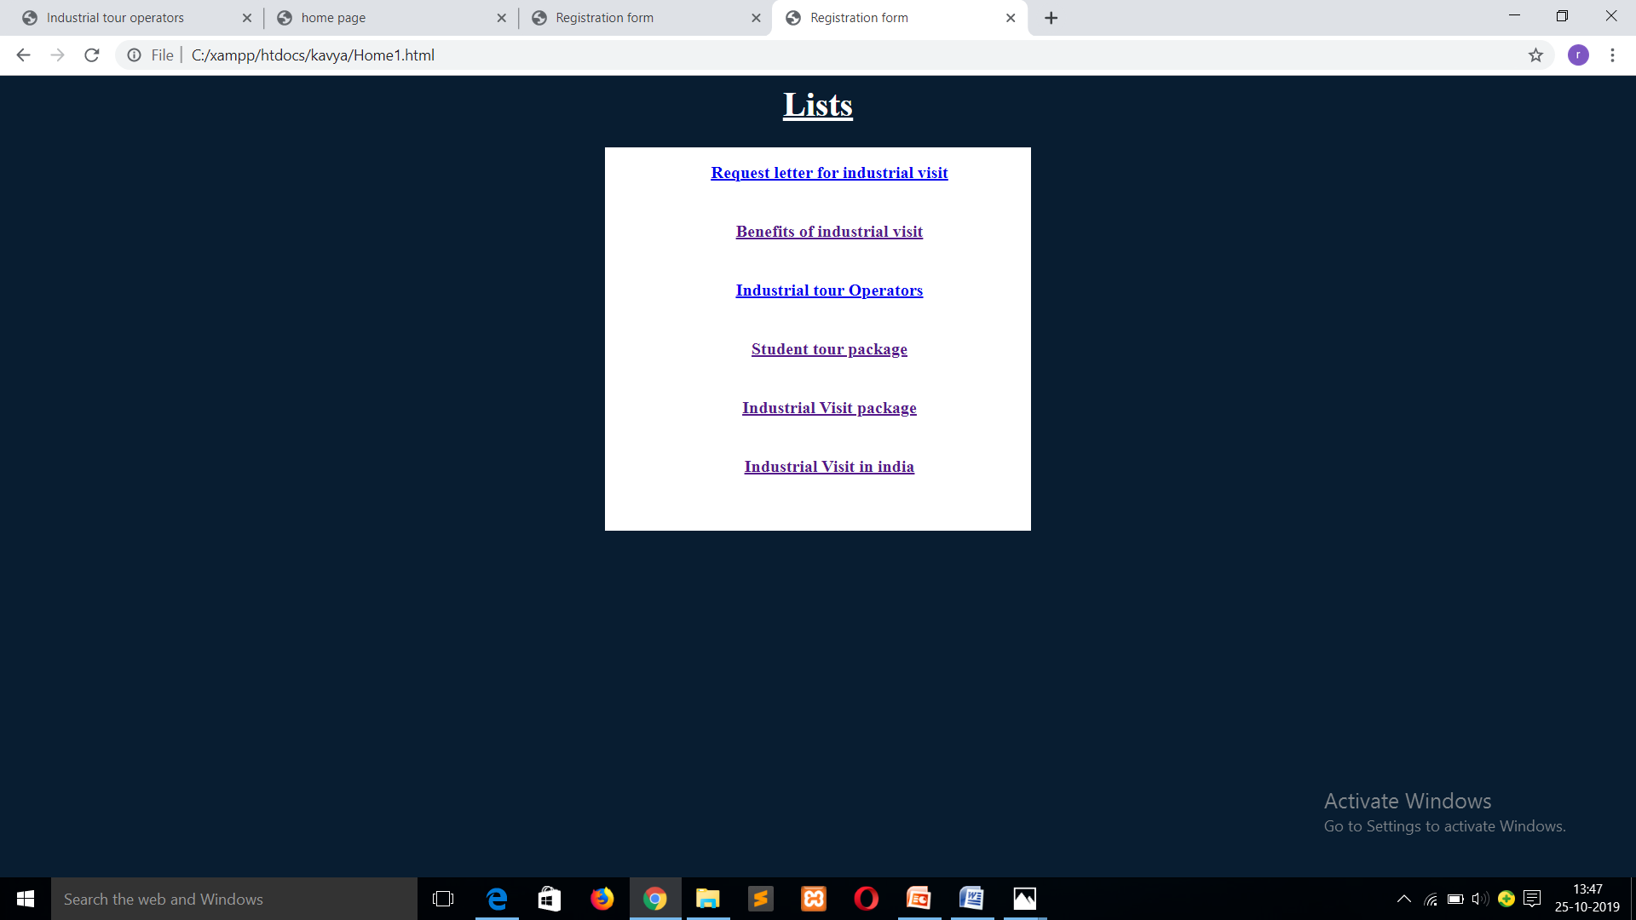

**Fig 3.Home page**

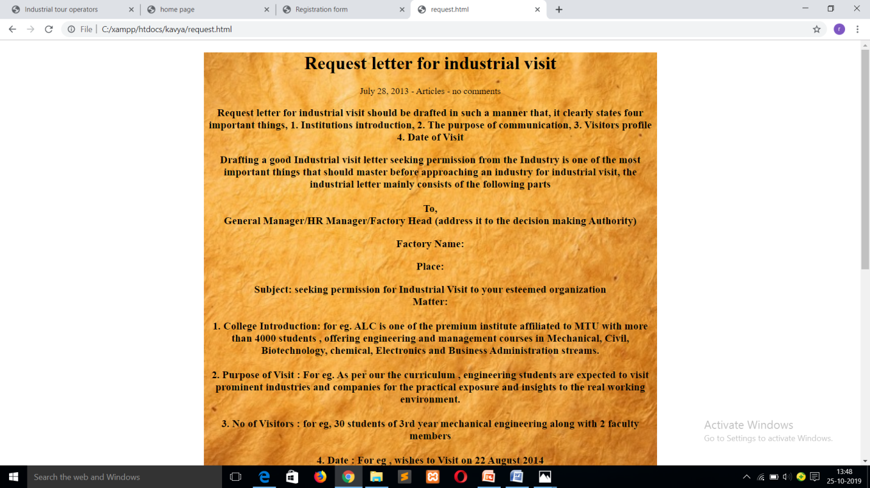

**Fig 3.1.request letter**

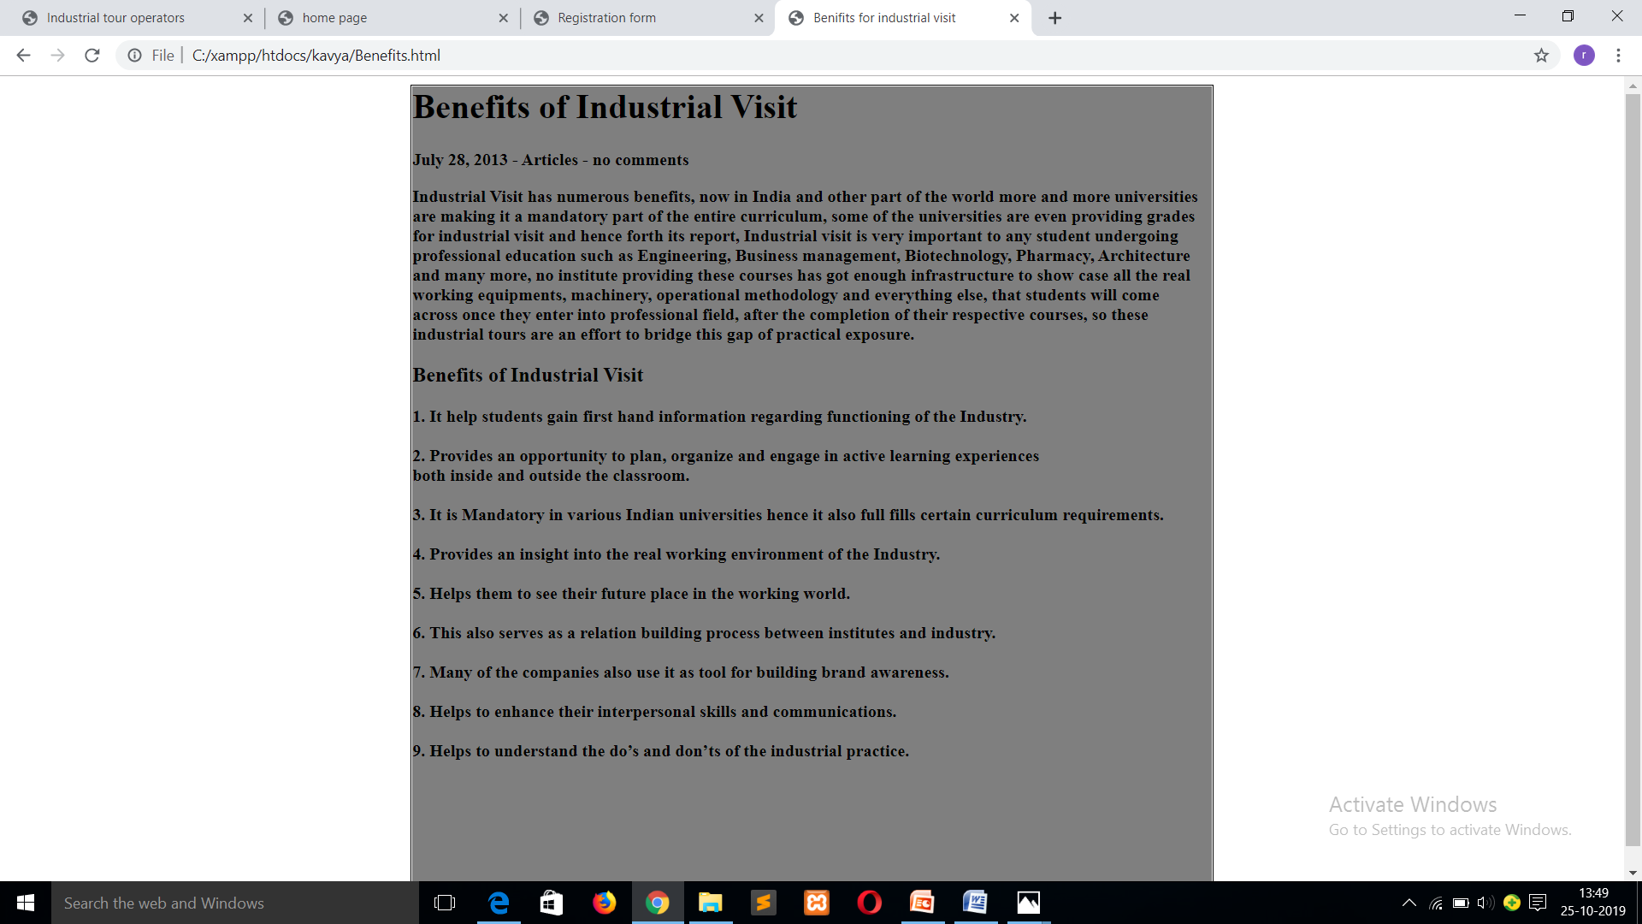

**Fig 3.2.Benefits**

**INDUSTRIAL TOUR OPERATORS**

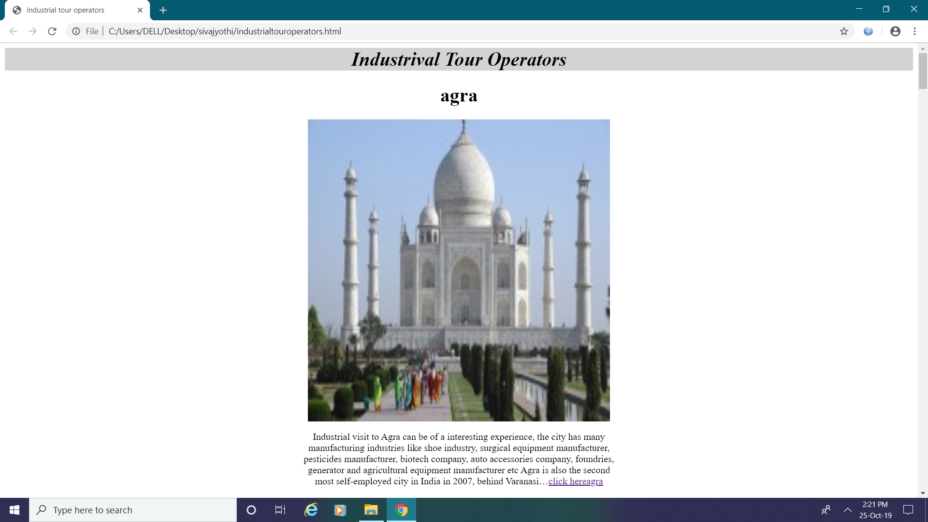 **Fig 3.3.1.Agra** 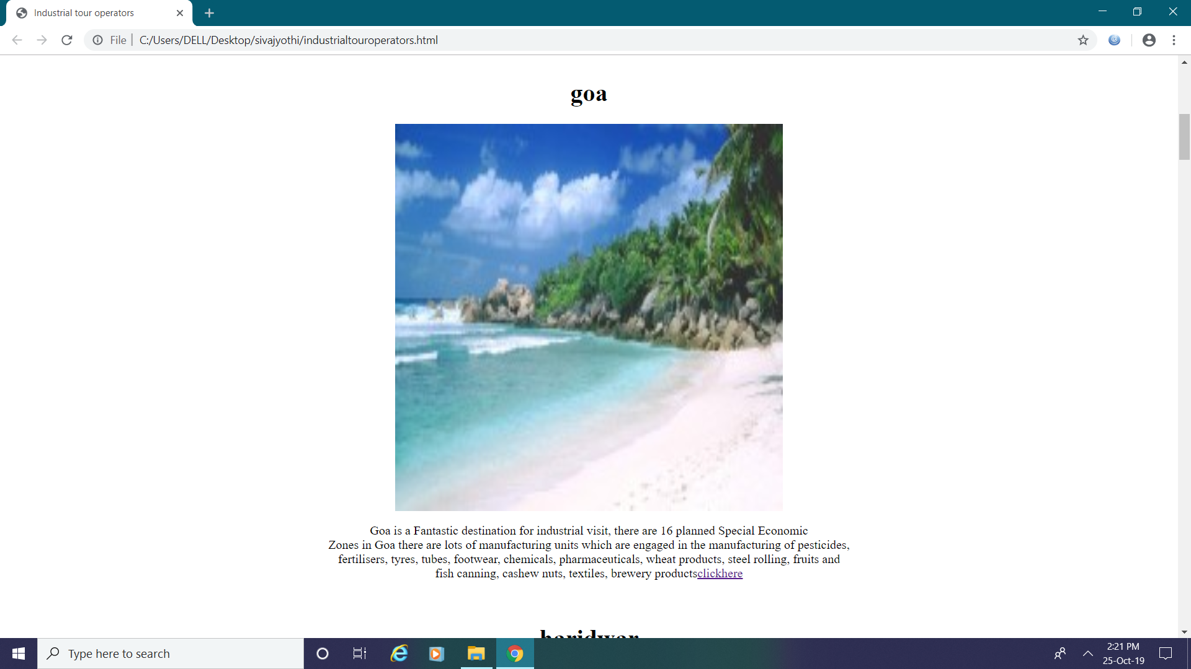

**Fig 3.3.2 goa**

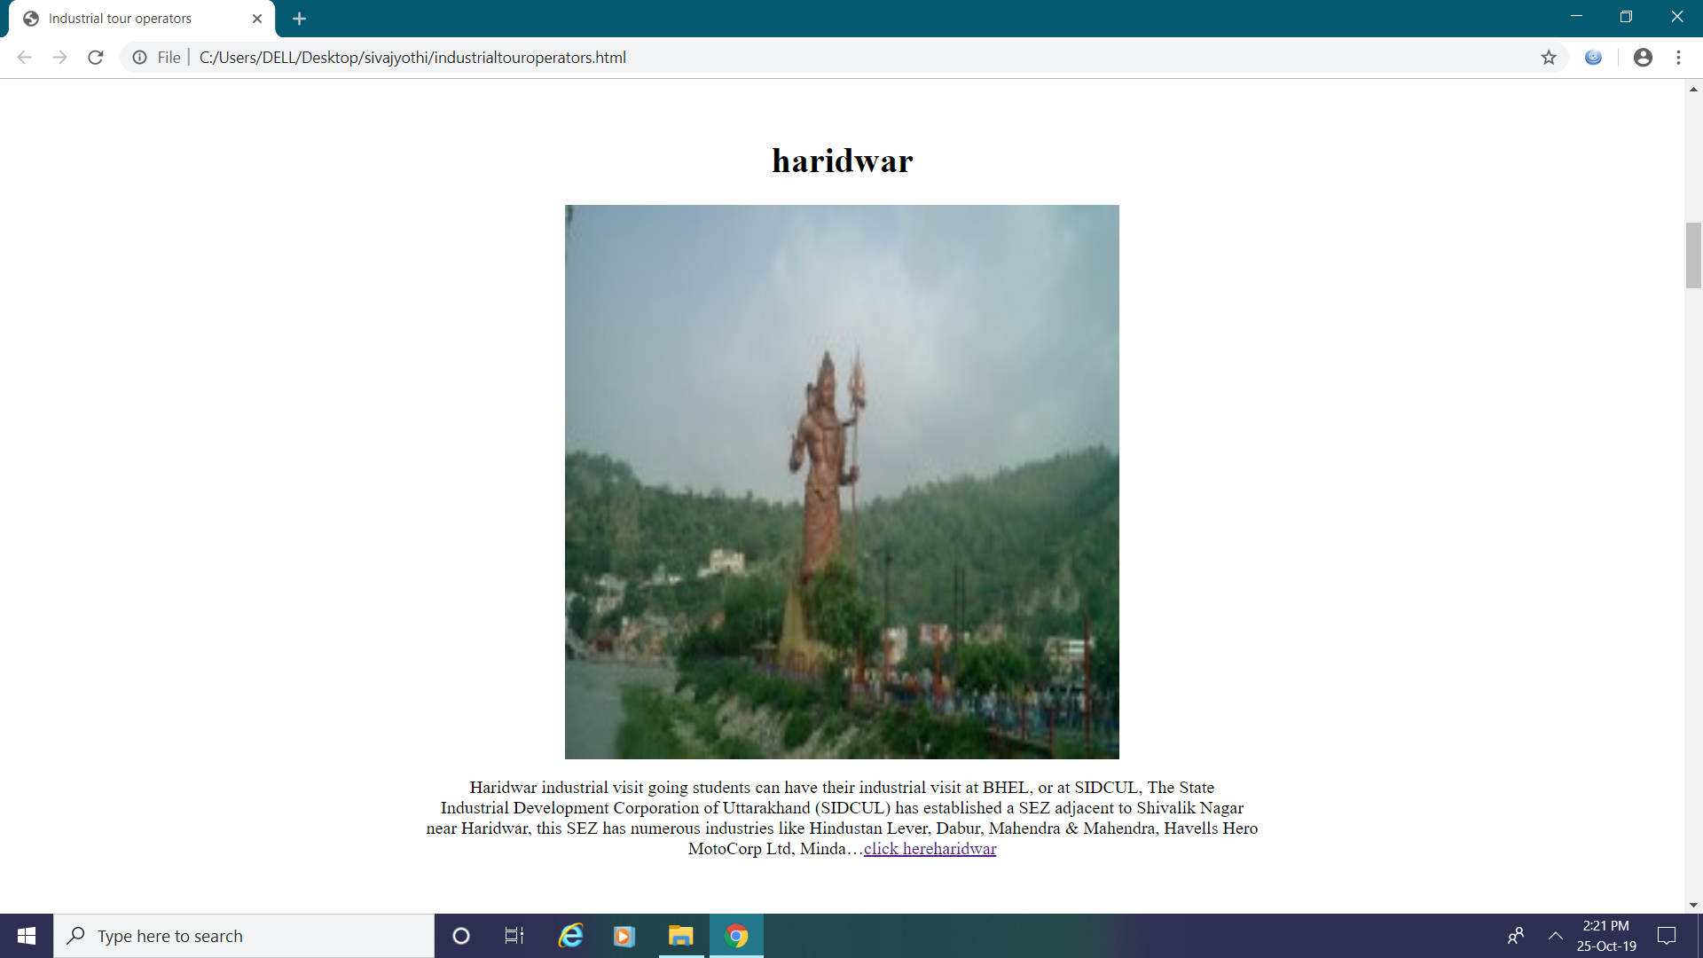

**Fig 3.3.3Haridwar**

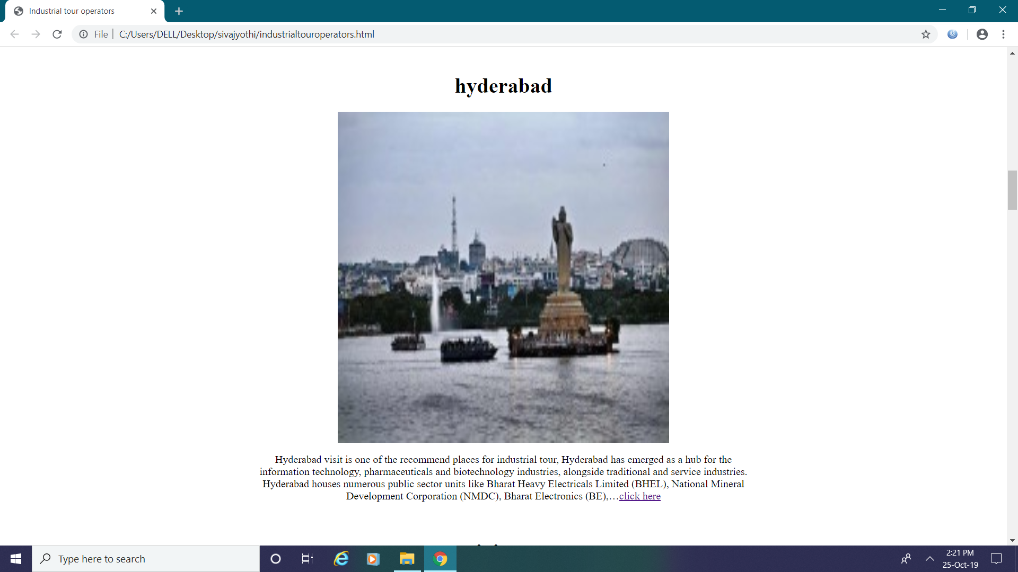

**Fig 3.3.4 Hyderabad**

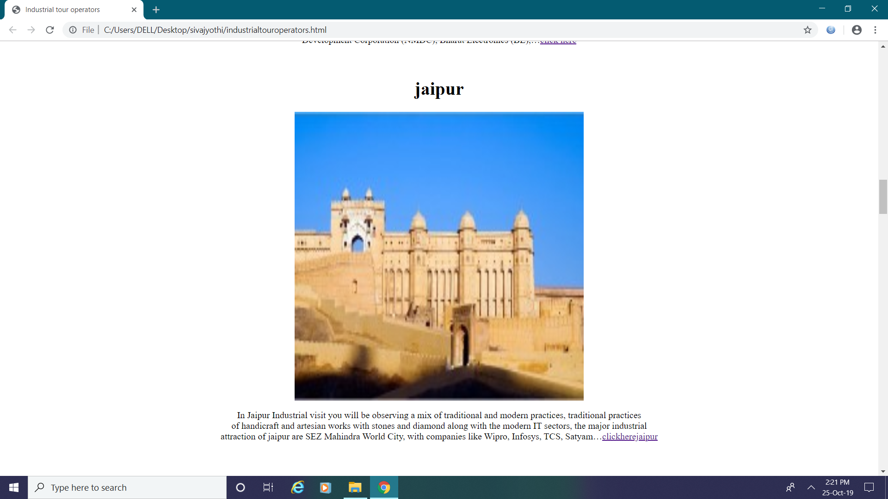

**Fig 3.3.5 Jaipur**

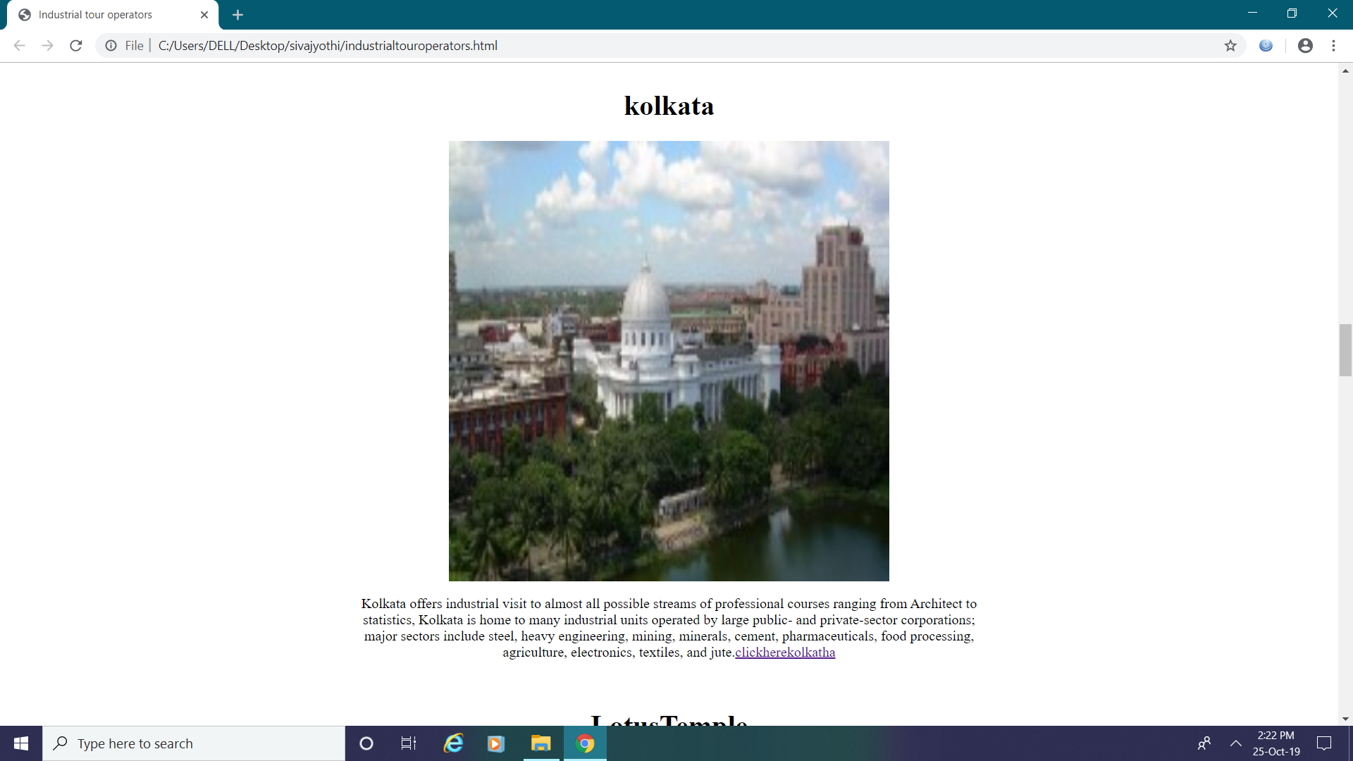

**Fig 3.3.6.Kolkata**

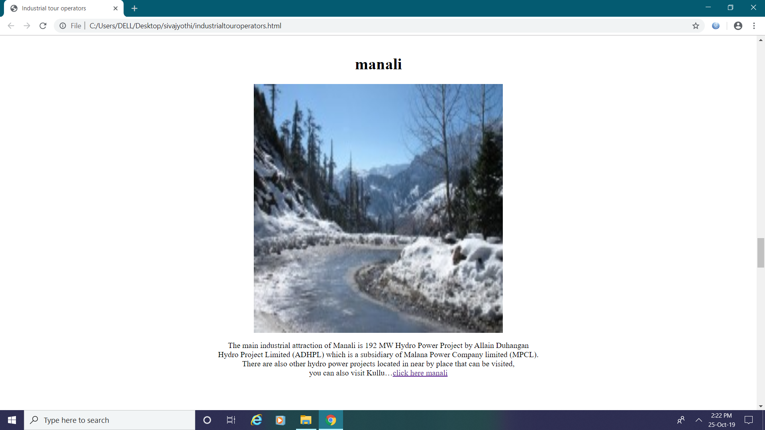

**Fig 3.3.7 Manali**

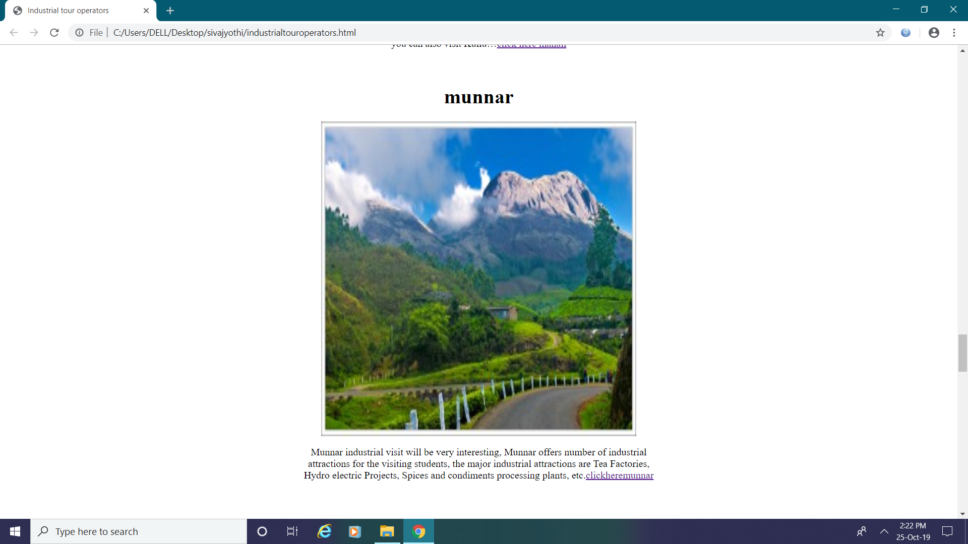

**Fig 3.3.8 Munnar**

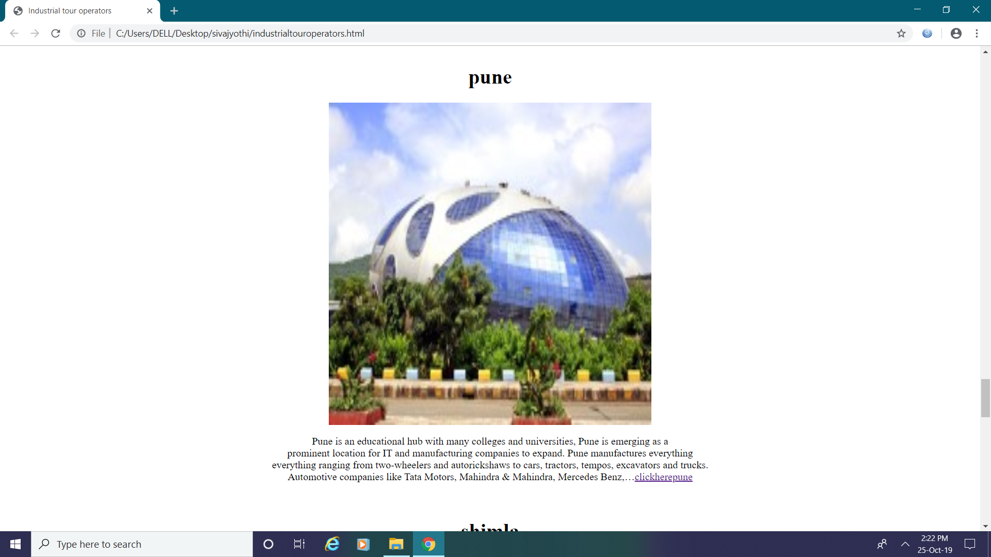

**Fig 3.3.8 Pune**

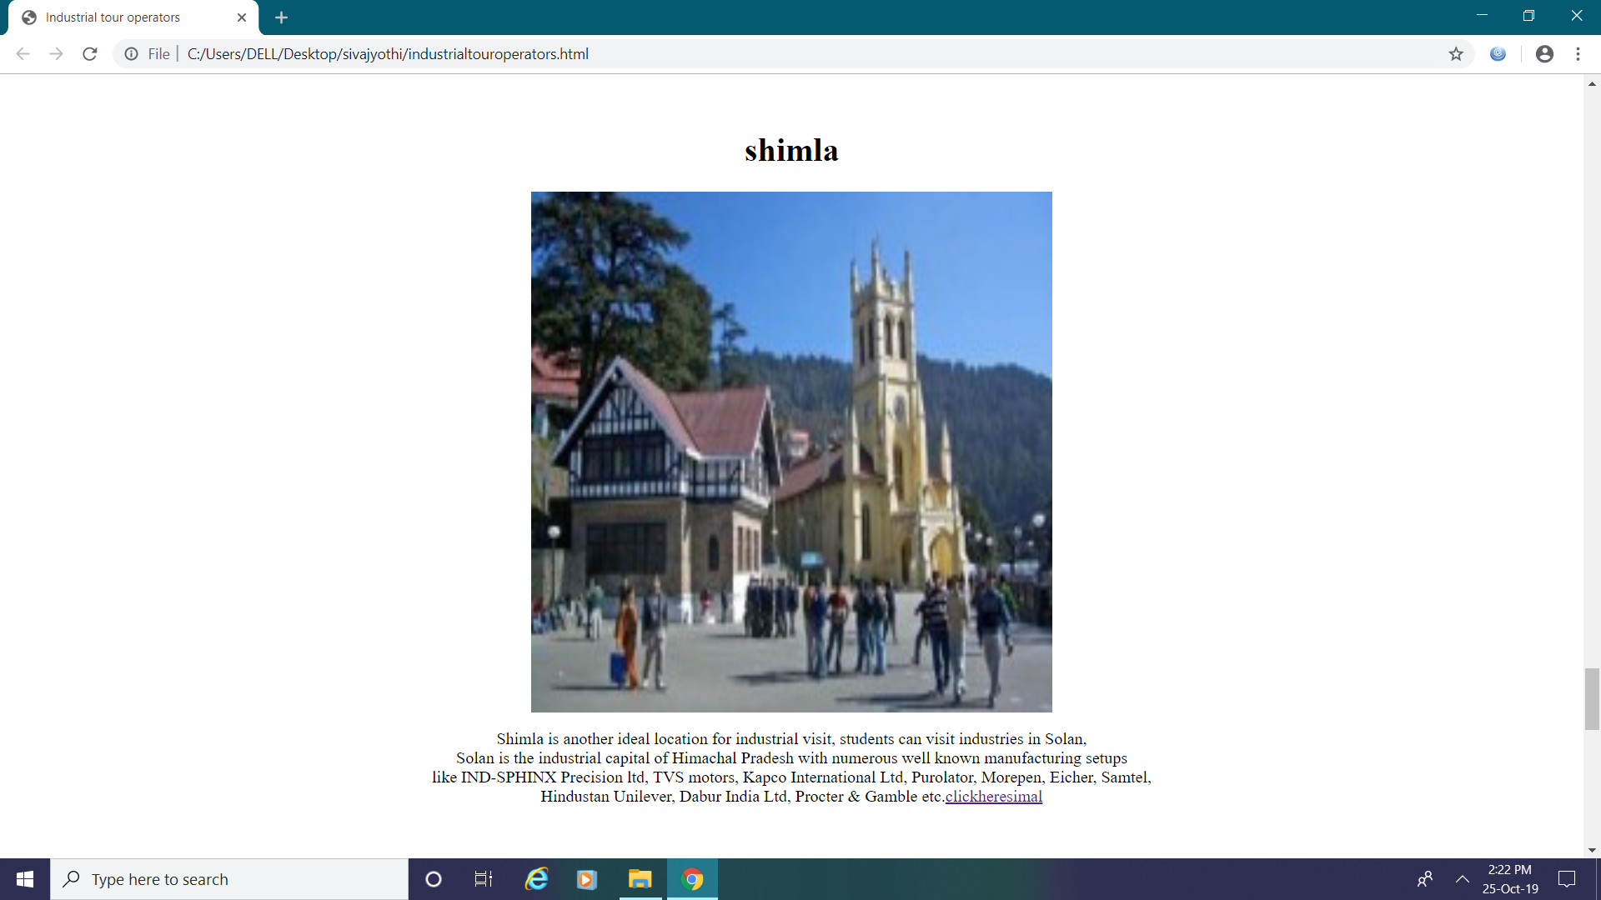

**Fig 3.3.9 Shimla.**

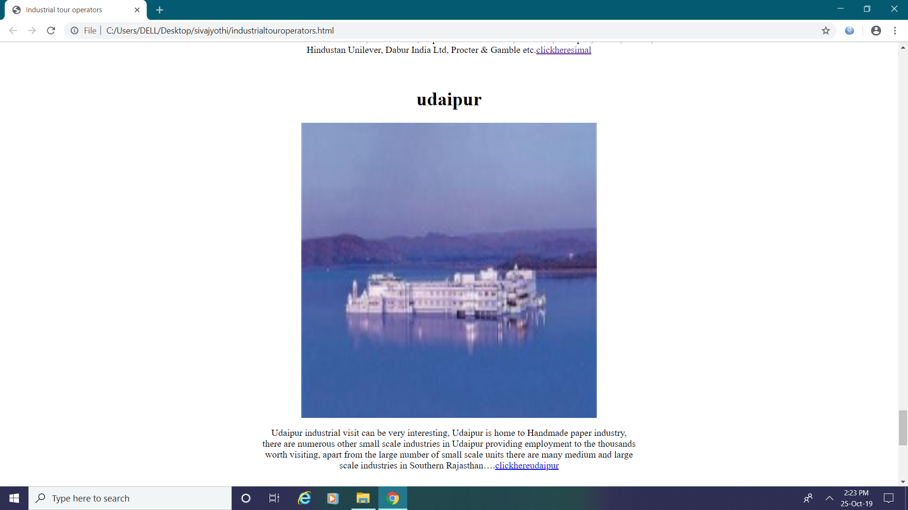

**Fig 3.3.10 Udaipur.**

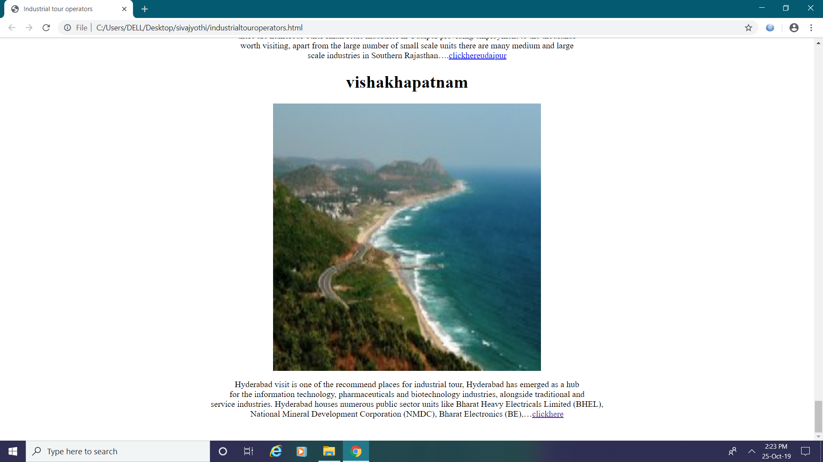

**Fig 3.3.11 Vishakapatnam**

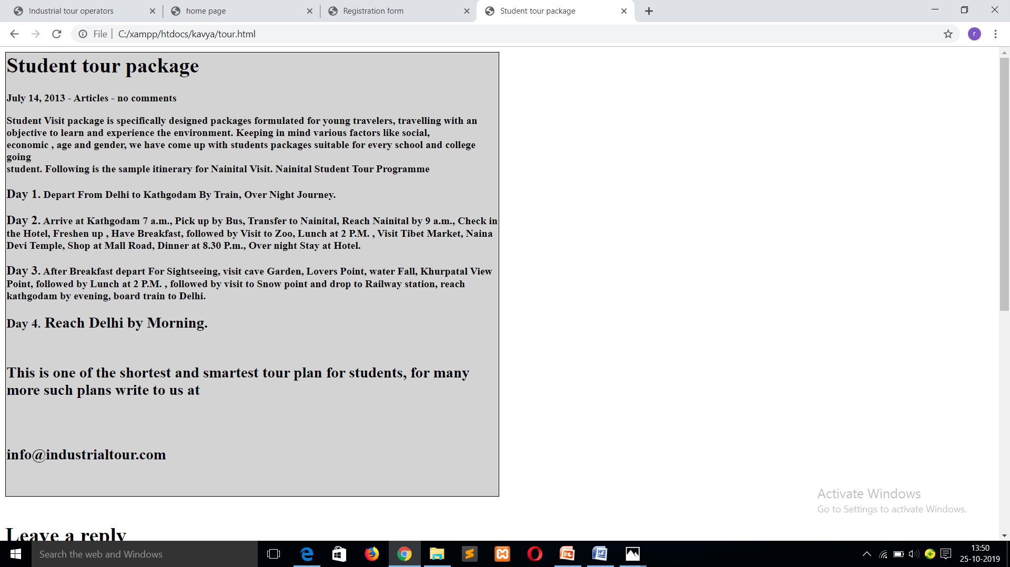

**Fig 4. Student tour package**

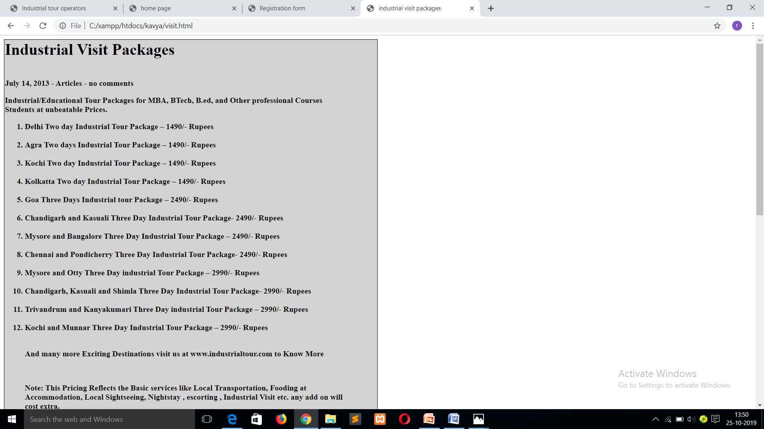

**Fig 5. Industrial visit package**

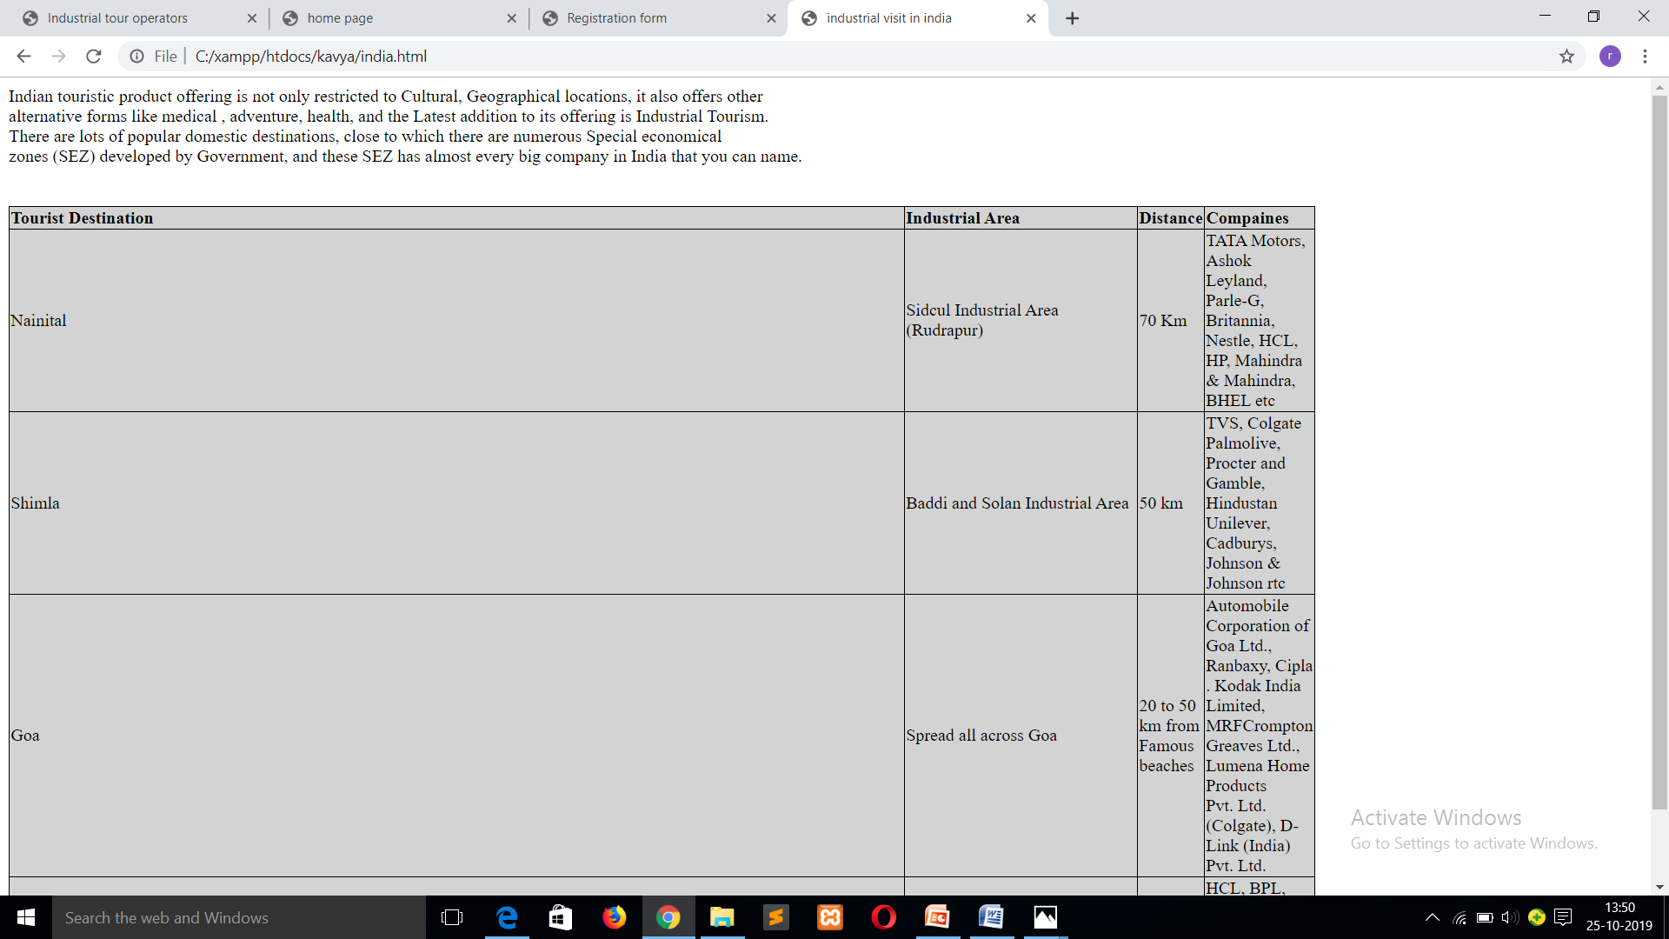

**Fig 6. Industrial visit in india**

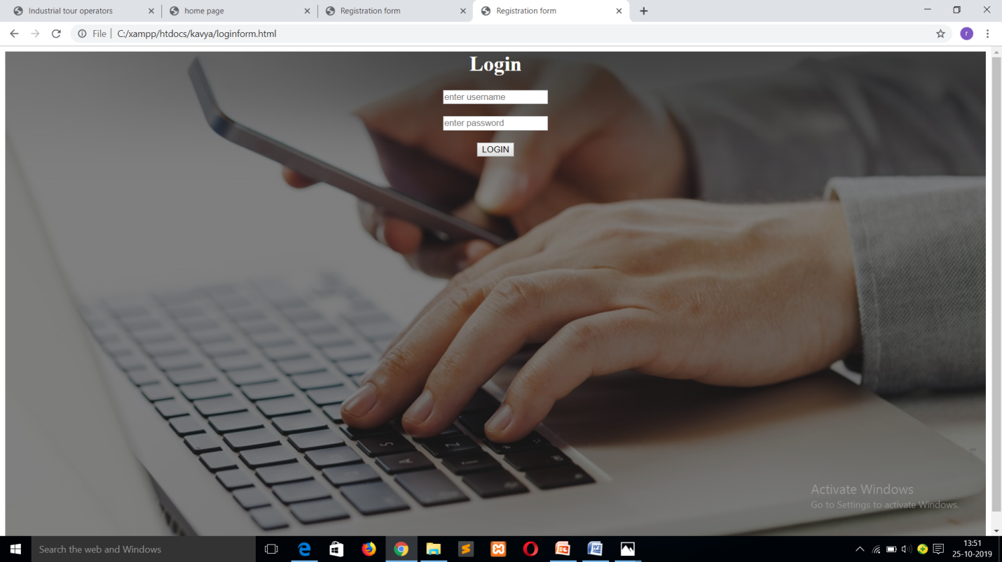

**Fig 7. Login page**

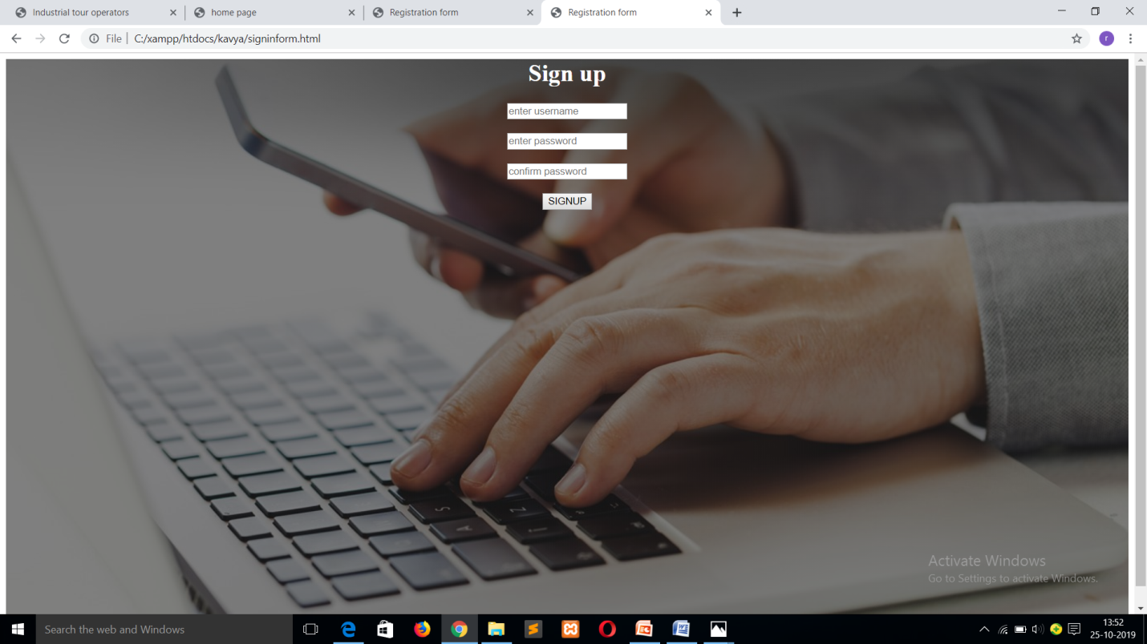

**Fig 8.Sign up page**

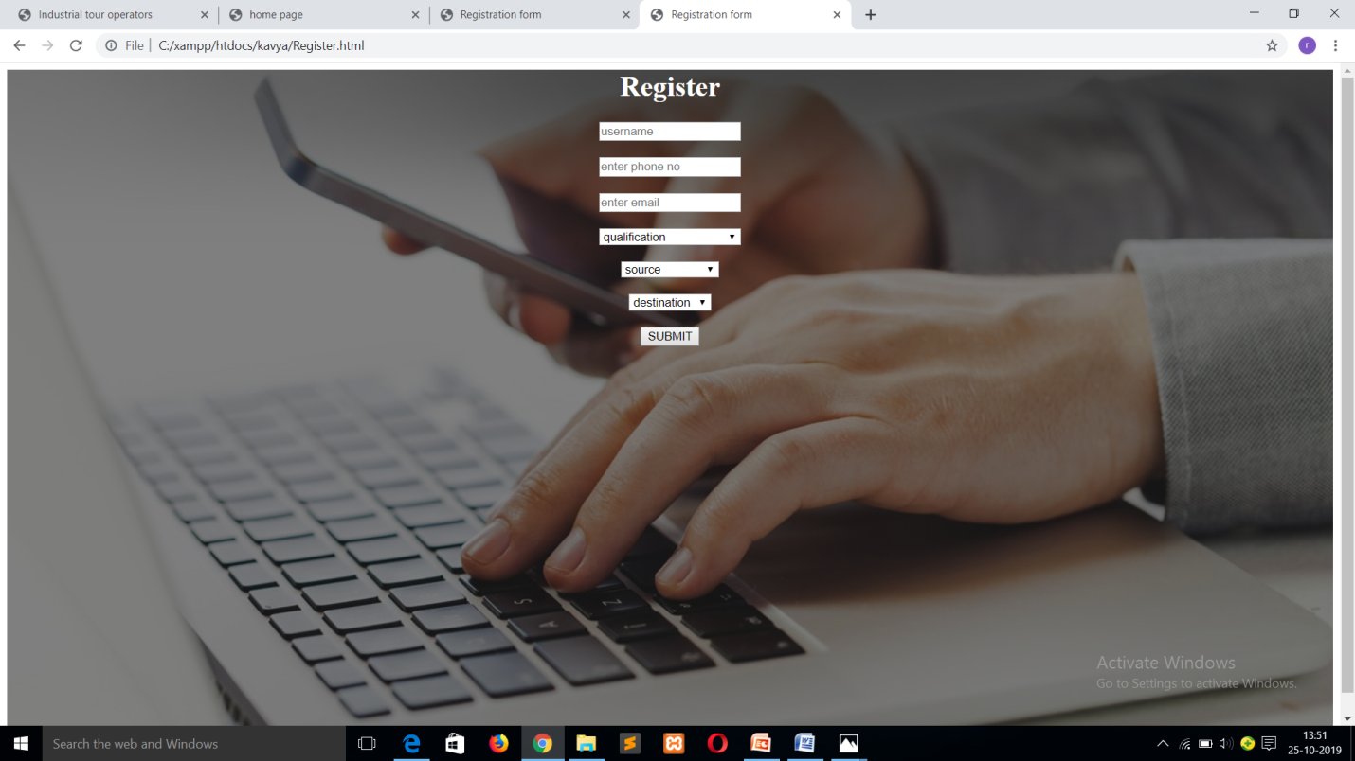

**Fig 9. Register page**

**TESTING**

**3.3 TESTING**

## 3.3.1. Introduction

In general, software engineers distinguish software faults from software failures. In case of a failure, the software does not do what the user expects. A fault is a programming error that may or may not actually manifest as a failure. A fault can also be described as an error in the correctness of the semantic of a computer program. A fault will become a failure if the exact computation conditions are met, one of them being that the faulty portion of computer software executes on the CPU. A fault can also turn into a failure when the software is ported to a different hardware platform or a different compiler, or when the software gets extended. Software testing is the technical investigation of the product under test to provide stakeholders with quality related information.

Software testing may be viewed as a sub-field of Software Quality Assurance but typically exists independently (and there may be no SQA areas in some companies). In SQA, software process specialists and auditors take a broader view on software and its development. They examine and change the software engineering process itself to reduce the amount of faults that end up in the code or deliver faster.

Regardless of the methods used or level of formality involved the desired result of testing is a level of confidence in the software so that the organization is confident that the software has an acceptable defect rate. What constitutes an acceptable defect rate depends on the nature of the software. An arcade video game designed to simulate flying an airplane would presumably have a much higher tolerance for defects than software used to control an actual airliner.

A problem with software testing is that the number of defects in a software product can be very large, and the number of configurations of the product larger still. Bugs that occur infrequently are difficult to find in testing. A rule of thumb is that a system that is expected to function without faults for a certain length of time must have already been tested for at least that length of time. This has severe consequences for projects to write long-lived reliable software.

A common practice of software testing is that it is performed by an independent group of testers after the functionality is developed but before it is shipped to the customer. This practice often results in the testing phase being used as project buffer to compensate for project delays. Another practice is to start software testing at the same moment the project starts and it is a continuous process until the project finishes.

Another common practice is for test suites to be developed during technical support escalation procedures. Such tests are then maintained in regression testing suites to ensure that future updates to the software don't repeat any of the known mistakes.

## 3.3.2Definition

Software Testing is the process used to help identify the correctness, completeness, security, and quality of developed computer software. Testing is a process of technical investigation, performed on behalf of stakeholders, that is intended to reveal quality-related information about the product with respect to the context in which it is intended to operate. This includes, but is not limited to, the process of executing a program or application with the intent of finding errors. Quality is not an absolute; it is value to some person. With that in mind, testing can never completely establish the correctness of arbitrary computer software; testing furnishes a criticism or comparison that compares the state and behavior of the product against a specification. An important point is that software testing should be distinguished from the separate discipline of Software Quality Assurance (SQA), which encompasses all business process areas, not just testing.

There are many approaches to software testing, but effective testing of complex products is essentially a process of investigation, not merely a matter of creating and following routine procedure. One definition of testing is "the process of questioning a product in order to evaluate it", where the "questions" are operations the tester attempts to execute with the product, and the product answers with its behavior in reaction to the probing of the tester[citation needed]. Although most of the intellectual processes of testing are nearly identical to that of review or inspection, the word testing is connoted to mean the dynamic analysis of the product—putting the product through its paces. Some of the common quality attributes include capability, reliability, efficiency, portability, maintainability, compatibility and usability. A good test is sometimes described as one which reveals an error; however, more recent thinking suggests that a good test is one which reveals information of interest to someone who matters within the project community.

## 3.3.4 Testing Methodologies

## 3.3.4.1Black Box Testing

It is the testing process in which tester can perform testing on an application without having any internal structural knowledge of application. Usually Test Engineers are involved in the black box testing.

## 3.3.4.2 White Box Testing

It is the testing process in which tester can perform testing on an application with having internal structural knowledge. Usually The Developers are involved in white box testing.

## 3.3.4.3 Gray Box Testing

It is the process in which the combination of black box and white box tonics’ are used.

## 3.3.4.4Typed of Testing

* + Regression Testing.
  + Re-Testing.
  + Static Testing.
  + Dynamic Testing.
  + Alpha Testing.
  + Beta Testing.
  + Monkey Testing
  + Compatibility Testing.
  + Installation Testing.

**> Regression Testing:** It is one of the best and important testing. Regression testing is the process in which the functionality, which is already tested before, is once again tested whenever some new change is added in order to check whether the existing functionality remains same.

**>Re-Testing:** It is the process in which testing is performed on some functionality which is already tested before to make sure that the defects are reproducible and to rule out the environments issues if at all any defects are there.

**Static Testing:** It is the testing, which is performed on an application when it is not been executed.

Ex: GUI, Document Testing

**Dynamic Testing:** It is the testing which is performed on an application when it is being executed.

Ex: Functional testing.

**Alpha Testing:** It is a type of user acceptance testing, which is conducted on an application when it is just before released to the customer.

** Beta-Testing:** It is a type of UAT that is conducted on an application when it is released to the customer, when deployed in to the real time environment and being accessed by the real time users.

**Monkey Testing:** It is the process in which abnormal operations, beyond capacity operations are done on the application to check the stability of it in spite of the users abnormal behavior.

**Compatibility testing:** It is the testing process in which usually the products are tested on the environments with different combinations of databases (application servers, browsersetc.) In order to check how far the product is compatible with all these environments platform combination.

**Installation Testing:** It is the process of testing in which the tester try to install or try to deploy the module into the corresponding environment by following the guidelines produced in the deployment document and check whether the installation is successful or not.

**4.CONCLUSION**

**4.1 CONCLUSION**

The Industrial visit gives a lot of information about various aspects of production, marketing as well as the operation of a company. The dissemination of knowledge by the support organization also gives a clear scope to the transactional analysis of the company. Through the visit, we gain information and practical knowledge about various manufacturing processes. The industrial visit gave a insight into the manufacturing, testing and distribution of products.Industrial visit offer a great source to gain practical knowledge to your curriculum, so you get to learn things which are beneficial to you in the future to master the field or scope, everything is covered in an industrial visit.

**4.2 FUTURE ENHANCEMENT**

Students will observe and learn on however theoretical ideas are placed into action, thereby aiding their practical learning. Students are exposed to real working atmosphere and shown however things are done in an organization. With regular Industrial visits, the students are able to identify their prospective area of work like marketing, finance, logistics, etc. This also gives students a platform to enhance their interpersonal skills.

**BIBLIOGRAPHY**

**BOOKS WRITTERS**

|  |  |  |  |
| --- | --- | --- | --- |
| 1. Developing PHP Applications for IBM Data Servers | Whei-Jen Chen, Holger Kirstein, Daniel Krook, Kiran H Nair, Piotr Pietrzak | | |
| 1. Programming PHP | | Rasmus Lerdorf, Kevin Tatroe |
| 1. PHP 5 Power Programming | | Andi Gutmans, Stig Bakken, Derick Rethans |
| 1. Practical PHP Programming | | Paul Hudson |

**LINKS**

1. www.w3schools.com/**php**/
2. www.**php**.net/
3. en.wikipedia.org/wiki/**PHP**
4. www.planet-**php**.net/

**BIBLIOGRAPHY**

**BOOKS WRITTERS**

|  |  |  |  |
| --- | --- | --- | --- |
| 1. Developing PHP Applications for IBM Data Servers | Whei-Jen Chen, Holger Kirstein, Daniel Krook, Kiran H Nair, Piotr Pietrzak | | |
| 1. Programming PHP | | Rasmus Lerdorf, Kevin Tatroe |
| 1. PHP 5 Power Programming | | Andi Gutmans, Stig Bakken, Derick Rethans |
| 1. Practical PHP Programming | | Paul Hudson |

**LINKS**

1. www.w3schools.com/**php**/
2. www.**php**.net/
3. en.wikipedia.org/wiki/**PHP**
4. www.planet-**php**.net/